**University of Toronto**  
**Faculty of Applied Science & Engineering**  
**APS112: *Conceptual Design Specification (CDS)***

|  |  |  |  |  |  |  |
| --- | --- | --- | --- | --- | --- | --- |
| Team # | 095 | | Tut # | 0114 | Date | Mar 25, 2024 |
| TA | Graeme Aylward | | CI | Emily Anglin | EM | Konstantinos Plataniotis |
| Client Name | | Alyssa Ahmed | | | | |
| Project Title | | Sussex Clubhouse Space Audit | | | | |
| Prepared By  (Names & Student #s*)  * Remove Student #s before submitting revised assignment to your client. | | Matthew Ting  Lydia Messiha  Dora Lyu  Anjali Jammulamadaka  Margaret Chen  Chris Yip | | | | |

Complete the checklist below before submitting your assignment to Quercus for grading. Remove This paragraph, your student numbers above, and the checklist below before submitting the revised assignment to your client. Do not remove the Disclaimer.

|  |  |  |  |
| --- | --- | --- | --- |
| _✔_ CDS submitted as a PDF to Quercus with the following components: | | | |
| _✔_ Cover Page | | | _✔_ Alternative Designs Selection Process |
| _✔_ Executive Summary | | | _✔_ Alternative Design Descriptions |
| _✔_ Introduction | | | ✔__ Proposed Conceptual Design Specification |
| _✔_ Problem Statement | | | _✔_ Measures of Success |
| _✔_ Service Environment | | | ✔__ Conclusion |
| _✔_ Stakeholders | | | _✔_ Reference list |
| _✔_ Detailed Requirements (FOCs) | | | ✔__ Appendices |
| _✔_ Generation, Selection and Description | | | ✔Attribution Table |
| If any required components are missing, your assignment is considered incomplete and standard late penalties will accrue until it is submitted completely. | | | |
| _✔_ Attribution table with ALL team members’ signatures submitted as a PDF to Quercus. An incomplete or missing attribution table will result in zero on the assignment for the team. | | | |
| __ Check this box if you used AI in this assignment. | | | |
| 3290 | Words | What is your word count? (Word count excludes Cover Page, Executive Summary, Reference List and Appendices) | |

**Disclaimer:**

**The design presented in this report has been prepared by first-year engineering students at the University of Toronto and does not present a Professional Engineer design. A Professional Engineer has not reviewed this design for technical accuracy or adequacy. The recommendations of this design may not be implemented in any way unless reviewed by a licensed Professional Engineer where professional or legal standards require such review and approval; it is understood that is the responsibility of the recipient of the design to assess whether such a requirement exists. This report may not be reproduced, in whole or in part, without this Disclaimer.**

**© Engineering Strategies and Practice, University of Toronto, 2024**

**Permission to reproduce material from this report may be requested by email to the Team’s contact and by copying the Engineering Strategies and Practice Office at esp@engineering.utoronto.ca.**

# 

# 

# Executive Summary

Alyssa Ahmed, the coordinator of Student Life at the University of Toronto’s Sussex Clubhouse has expressed several concerns to our team about the building’s current arrangement. People are not able to move around the building efficiently, there is a decrease in students that visit the clubhouse as a result of the pandemic, and the design does not have an efficient storage system. The goal of this project is to find a solution that fits these issues. To assess the validity of the solutions, a list of quantified objective goals and constraint limits can help compare each solution to determine the design that best satisfies the client’s needs.

The primary function of the Sussex Clubhouse is to provide a free meeting and workspace for clubs and the staff of the University of Toronto. The secondary functions emphasize the need for a collaborative space as well as moving within rooms comfortably. Set goals have been implemented in each solution to maximize solution impact. These objectives include maximizing the utilization of space and having a universal usage of durable and robust furniture and storage that minimizes cost while staying secure and flexible. The constraints of the project were formed to create firm limits of each solution. These boundaries include following building room capacity codes for the City of Toronto as well as keeping all renovations within the first 2 weeks in June. The Space Audit project is scoped to the 4th, 5th and 6th floors solely for club room renovations. The primary stakeholders of this project are the Institutional Equity Office at U of T, the Government of Ontario’s Ministry of Municipal Affairs and Housing, and the surrounding Toronto Community who possess great impacts from this project.

In our ideation process, the team used methods such as brainstorming, a SCAMPER Table and the benchmarking of existing UofT buildings to generate a total of 63 storage and space based solutions. Ideas were then removed through a feasibility check, multi-voting, a graphical decision chart, a weighted decision matrix, and a pugh chart to rank our final three alternate designs. Our first solution, “Aris”, utilizes drawers, drawer dividers, and sleeve storage to implement better drawer storage in the meeting spaces. Our second solution, “Pandora'', aims to divide the meeting rooms into storage and meeting space while using closet and hanging door organizers, stacked storage organizers, and shrinkable furniture to maximize space in the room. Our third solution, “Proteus”, creates a designed pathway around each room to better navigate while also implementing multi-purpose furniture such as ottoman seating and foldable tables and chairs.

The next steps for the team are to follow up with the client on the proposed solution, receive feedback on how well the needs are met, and adapt the proposed solution to further changes. A modeled layout will be presented to the client and club leaders. From there the success of an iteration will be measured by completing more user tests on-site.

# 1.0 Introduction

21 Sussex Ave, located in Toronto ON, is an establishment that houses 50 student groups on the 4th, 5th, and 6th floors. This building also serves as an office space for the St.George Campus Safety Special Constable Service [1] and the University of Toronto’s Student Newspaper, the Varsity [2]. Alyssa Ahmed, the student life coordinator, requests to reassess and remodel the building’s 4th, 5th, and 6th floors [3] to better suit the student’s needs.

# 

Figure 1: *Exterior of the Sussex*

**2.0 Problem Statement**

The problem to be addressed around the Sussex Clubhouse is the deficiency in the layout of the space which poses a significant hindrance to students coming to the Clubhouse.(here is the current layout of the clubhouse) The current layout of the Clubhouse consists of small meeting rooms without proper storage as shown in Figure 2. It makes it difficult to move around the rooms and thus discourages more students from visiting the Clubhouse.

The client needs a lively community environment to foster student collaboration and creativity with an efficient storage solution catering to the users’ needs. The Clubhouse needs a reassessment of the current space andstorage solution.

The redesign covers the 4th to 6th floors of the Clubhouse building and has been scoped to general meeting rooms, club rooms, and storage areas. The engineering team is required to come up with effective solutions to give students more space for club-related storage while maximizing the club room space for meetings and social events.

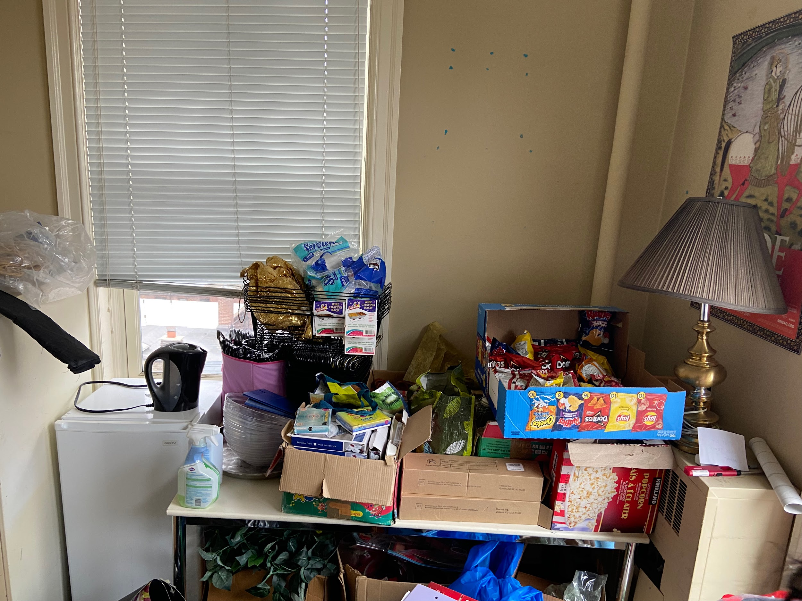

Figure 2: *Existing storage situation (using the desk as storage)*

# 3.0 Service Environment

This section provides an overview of the environment within the Sussex Clubhouse, offering insights into the environmental conditions of the room sizes, area distribution, aging facilities, and storage capabilities.

# *3.1.0* *Physical Environment*

The following table describes the diagram and metrics of the building measurements.

Table 1. *The physical environment with diagrams and metrics*

|  |  |
| --- | --- |
| **Diagrams** | **Metrics** |
| See Appendix F for floor plans of the 4th, 5th, and 6th floors of the Clubhouse. | **Room Sizes**:  The dimensions of the rooms range from approximately 5 to 10 square meters. |
| Figure 3. *Disorganized storage in Room 529* | **Storage Capabilities**:  Several rooms are significantly cluttered, leaving minimal room for people to maneuver around. |
| Figure 4. *Dance Studio* | **Building Age**:  In 1966, the University of Toronto expropriated the property at 21 Sussex Avenue. By the early 21st century, the University of Toronto subsequently renovated it into office spaces for academic and student-led organizations.[4] |
| **Area Distribution:**   * The 4th floor has 4 common areas and 12 club rooms, with two clubs sharing one club room. * The 5th floor has 2 common areas and 10 club rooms, with two clubs sharing one club room. * The 6th floor has 7 club rooms, with each club having its dedicated room. * 1-2 rooms are allocated for large storage lockers from the 4th-5th floor.   (See Appendix D) | |

# *3.2.0 Living Things*

Based on the engineering team’s site observation, the number of people club rooms can hold is up to a maximum of 20 [5] and a minimum of 6. Club members will occupy the space mostly from 4 to 7 pm and staff will occupy the space for their office [3].

# *3.3.0 Virtual Environment*

Every student and staff in the building can access the University of Toronto WiFi system [6].

# 4.0 Stakeholders

This section determines the stakeholders relevant to the Clubhouse redesign, including the Institutional Equity Office U of T, the Government of Ontario’s Ministry of Municipal Affairs and Housing, and the community. The following table shows the impact of the project on the stakeholders.

Table 2. *Stakeholders of the Sussex Clubhouse project*

|  |  |  |
| --- | --- | --- |
| Stakeholder | Interest Category | Impact on Stakeholders |
| Institutional Equity Office at U of T | Social | * support clubs focusing on anti-racism, cultural, sexual, and gender diversity guided by the Institutional Equity Office (IEO).[7] |
| Government of Ontario’s Ministry of Municipal Affairs and Housing | Legal | * There is a concern if this project follows relative regulations provided in the Toronto Municipal Codes Chapter 629 [8]. |
| Community | Social | * Can be disturbance to building occupants [9]. * Leisure noise above an average noise of 70 dBA (24-hour average) is not recommended by The World Health Organization [9] |

# 5.0 Detailed Requirements

This section highlights the requirements that each solution must follow to satisfy the client’s needs, a set of goals that each solution hopes to accomplish in the selection process and defined boundaries that each solution must not cross.

## *5.1 Functions*

This section analyzes the purpose of the clubhouse by classifying primary functions and secondary functions. The Black Box Method is used to identify functions that the design must complete to be a viable solution. (Appendix N).

Table 3. *Functions of the Sussex Clubhouse Project*

|  |  |  |
| --- | --- | --- |
|  | Function | Description |
| Primary Functions | Provide free meeting and work spaces for clubs and the staff of the University of Toronto | The clubhouse was designed to create a sense of community for club events. |
| Secondary Functions | Transport people around the clubhouse rooms | The design must improve the mobility for users to walk around the room. |
| Create a more lively space in the clubhouse building | The design must re-establish the community before the pandemic due to the large decrease in the number of visitors. |
| Provide a better storage system for clubs. | The design must provide a better storage option for more organized space and activities |

## 

## *5.2 Objectives*

This section describes the project’s storage and space objectives that will assess the design solutions. The objectives listed below have been put in a Pairwise Comparison Chart [Appendix E] to rank their importance. The project contains many intricacies related to each club and its requirements allowing for a wide range of objectives, metrics, and goals.

Table 4. *Space* *Objectives of the Sussex Clubhouse Project*

|  |  |  |
| --- | --- | --- |
| **Space Objectives** | Goals and Description | Metrics |
| Maximize utilization of space | The design should allow for clubs to get the most out of their space according to their needs [3].  This will help facilitate organized meetings and collaboration. | The design should allow for 1-6, 7-13, or 14-20 students to share space comfortably with one another [5] as Ontario room codes vary depending on size. |
| Universal usage of furniture | The furniture should be easy to maneuver [10] and create a unified workspace [11] rather than act as a hurdle within the space.  Furniture should add to the flexibility of the room. Clubs can move things according to their needs. [3] | The furniture should be able to withstand a minimum of one year of usage (the duration of most clubs) [3]. |
| Durable and Robust | Each club should be able to clean and keep up with the design in their room.  [11]  Space designs need to be durable and robust when dealing with different types of materials, equipment, and people coming in and out of the Clubhouse. | The design should have a maintenance frequency of 1 year [3] and clubs should be able to maintain whatever they take ownership of as frequently as one month to annually (depending on usage of the room, etc) [12] |
| Minimize cost | The design should follow the budget requirements placed by the client [3].  The design should be selected and built to maintain the rest of the objectives as well as staying conscientious of the budget. | The budget for space solutions should be below $10,000 as outlined by the client. [3] |

Table 5: *Storage Objectives of the Sussex Clubhouse Project.*

|  |  |  |
| --- | --- | --- |
| **Storage Objectives** | Goals and Description | Metrics |
| Durable and Robust | Storage should withstand a range of heavyweight equipment and materials to lightweight materials.  [3]  There are many different types of clubs with a wide variety of storage needs [3]. | The frequency of storage items being damaged due to poor storage can be tracked every month for a year [3]. The goal is a low incidental rate every year [13]. |
| Secure | Storage should be able to hold and secure sensitive club items that only club leaders have access to.  [3]  Many clubs will have personal equipment and expensive gear that require safe storage while they are out of the Clubhouse. | Security incident reports will track the number of incidents per month related to security. [14] We aim for 0 incidents a month from each club [3]. |
| Flexible | Storage should be easily adjusted to suit what each distinct club needs to store. [3].  The storage should account for the changing needs and requirements of each club. | Clubs should be able to reach a higher range of 22%-27% space utilization (as this is a warehouse standard, but we do not need to take into consideration workers and worker labour cost) [5] by calculating the total size of their storage, their inventory size, and the storage size.[5] |
| Minimize cost | The design should follow the budget requirements placed by the client [3]. | The budget for storage solutions should be below $10,000 as outlined by the client. [3] |

## *5.3 Constraints*

This section sets strict limits or boundaries for the design. The design must not exceed the constraints of the project.

Table 6. *Constraints of the Sussex Clubhouse project*

|  |  |
| --- | --- |
| Constraints | Metrics |
| Must not continue renovations after the allotted time frame. | Renovations must be completed within 2 weeks in June, as per the request of the client [16]. |
| Must not reach a maximum capacity of 20 people. | Metric of a maximum capacity of 20 people in the largest room of 22.21 m2 [5]. Appendix H contains the dimensions for the largest room. |
| Must not deconstruct room confinements (doors, windows, ceiling, walls), as there is asbestos in the walls. | Due to the hazards, 0 deconstructions should occur [16]. |
| Must not conflict with room designs initiated by the club. | 0 items should be removed without the club's permission [3]. |

# 

# 6.0 Idea Generation, Idea Selection and Alternate Designs

This section outlines how we generated and selected ideas based on the project requirements. We used benchmarking, SCAMPER, and general brainstorming in our ideation process which were categorized into storage efficiency, space efficiency and mobility. Ideas were selected through a feasibility check, multi-voting, a graphical decision chart, weighted matrix, and a pugh chart.

## 6.1 Idea Generation Process

This section describes the methods used to develop ideas for the Sussex Clubhouse redesign that satisfy the detailed requirements of the client. The idea-generation process began by coming up with 63 ideas through brainstorming and the utilization of the SCAMPER Table [Appendix E]. This list consisted of ideas conscious of improving the space and storage problems outlined by the client. The idea list was then completed with a specific description for each idea, making sure each idea outlines how it will solve the lack of space or allow for better storage within the rooms and storage area. A feasibility check was done to cut down to 48 realistic ideas. We then used a morph chart to combine these ideas to create individual solutions that attend to each function. This was necessary as there are many intricacies with this project (space and storage objectives), requiring various solutions tackling each area of concern for the client.

## 6.2 Idea Selection Process

The team utilized various methods to select final 3 design solutions as shown in Figure 7.

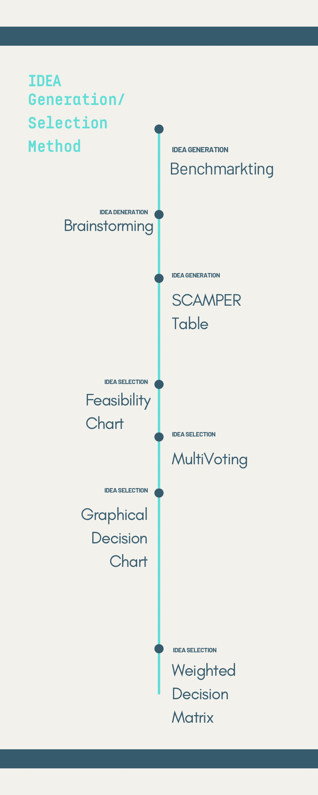

Figure 6. *Flowchart: idea generation and selection process*

The team began the idea selection process by using a feasibility chart to retain the most realistic ideas. Each idea was voted on based on predefined criteria including project relevance and practicality. Tied ideas were reorganized on a scale of 1-10 for a more precise assessment. This evaluation cut 63 ideas down to 48.

After the generation of 48 ideas through the morph chart, ideas were then evaluated based on multi-perspective preference[Appendix G], cutting 48 ideas down to 30.

A graphical decision matrix compared the two primary objective groups: storage and space objectives. This matrix displayed 15 ideas that did not meet our objectives. This evaluation cut 30 ideas down to 14.

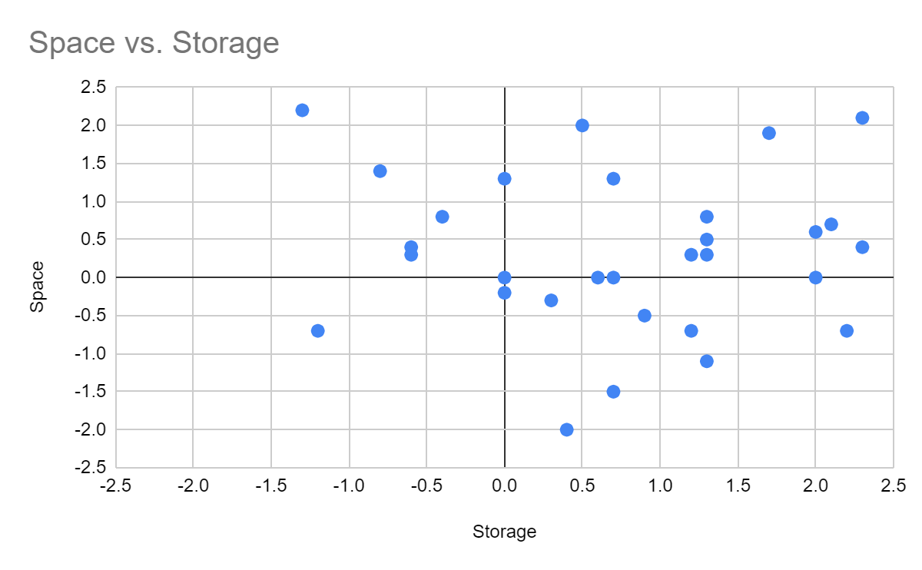

Figure 7. *Graphical Decision matrix*

To conclude the idea selection process and finalize three ideas, the team utilized their Objective Pairwise Comparison Charts [Appendix I]. The final weight for each objective was determined by calculating the percentage of its total score relative to the sum of scores for all objectives. The remaining 30 ideas were evaluated by assigning scores from 1-10 for how well each idea met each objective. Scores were added up which led to the top three highest scored ideas as the three alternate ideas the team will propose to the client [Appendix J].

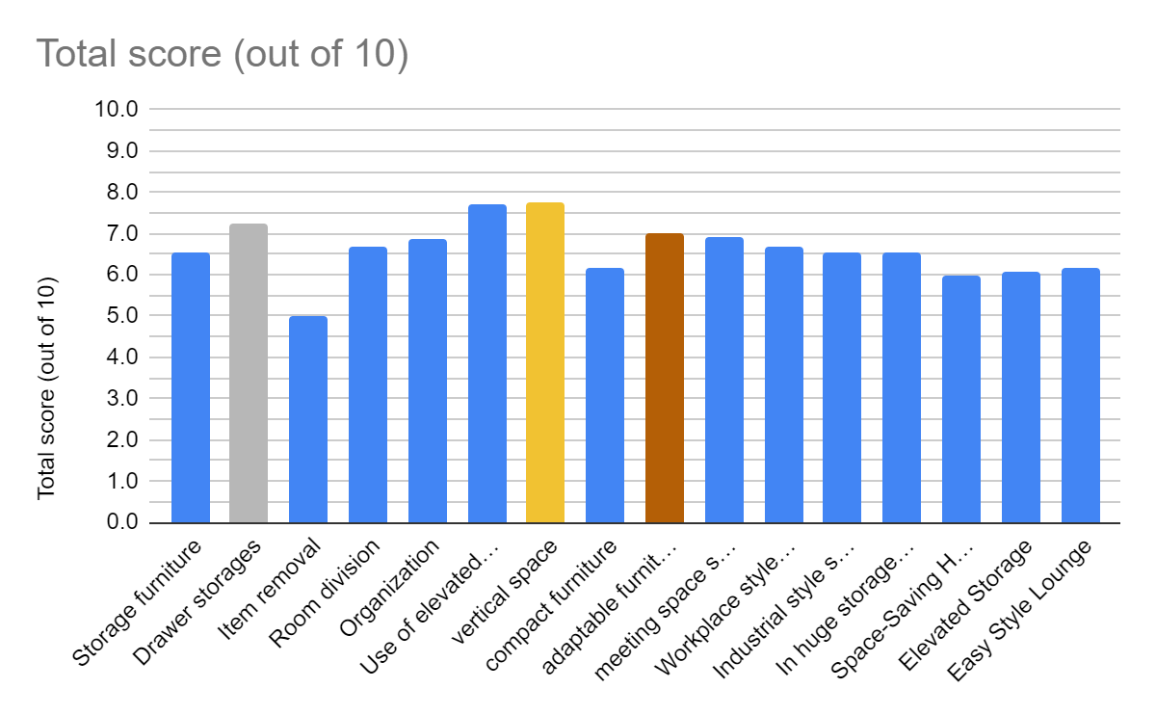

Figure 8. *Weighted decision matrix*

Themes such as space efficiency, storage and user experience were central to the ideation process. The team's diverse perspectives facilitated a comprehensive discussion over the merits and drawbacks of each design, ensuring the final selection was in alignment with the project's overarching goals.

## 6.3 Alternate Design Descriptions

This section outlines the developed three designs that have been chosen to be the most suitable for the Sussex Space Audit Project. All blueprints and solution items are chosen based on the scaled layout of the room.

### 

### *6.3.1 Design #1 -* Vertical Space: “Aris”

### 

### Figure 9. *Vertical Space solution blueprint incorporated into the storage room and room 505 of the clubhouse*.

Aris, the vertical space solution is designed to make use of elevated volumes of the room. The solution includes: stacking storage to a maximized height that is within reach with the use of a stepping stool, a hung storage system placed in the closet, hangers on doors, shelves placed along walls, shrinkable furniture and a division of the room between work and storage environments. In addition, this solution is an option for components in the storage room.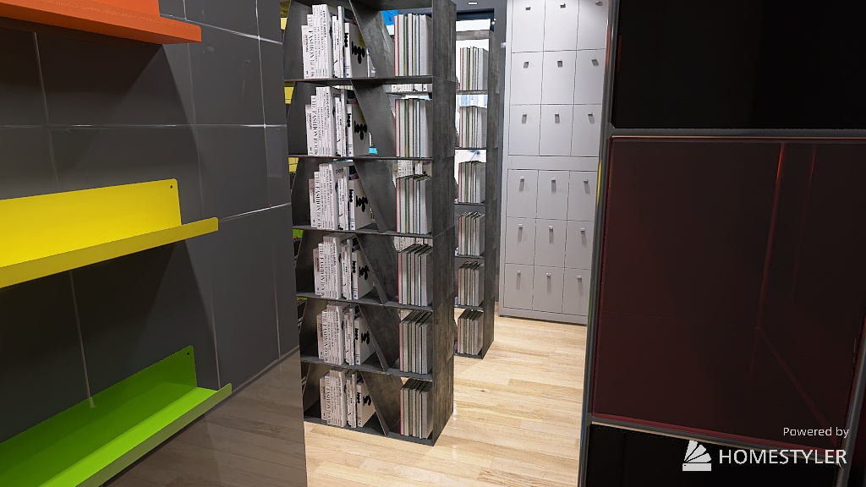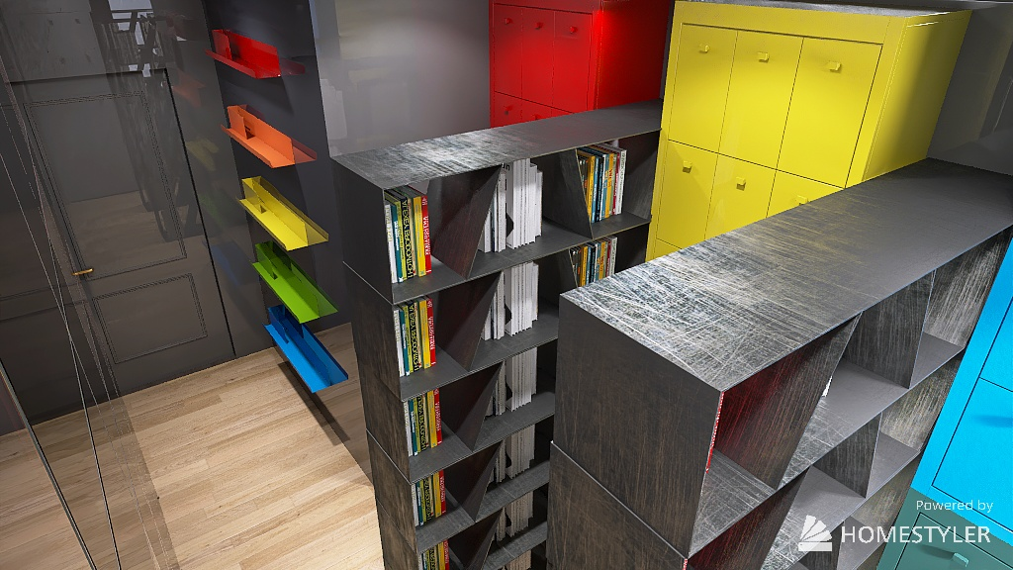

Figure 10. *Vertical space layout simulation in storage room made in Homestyler.*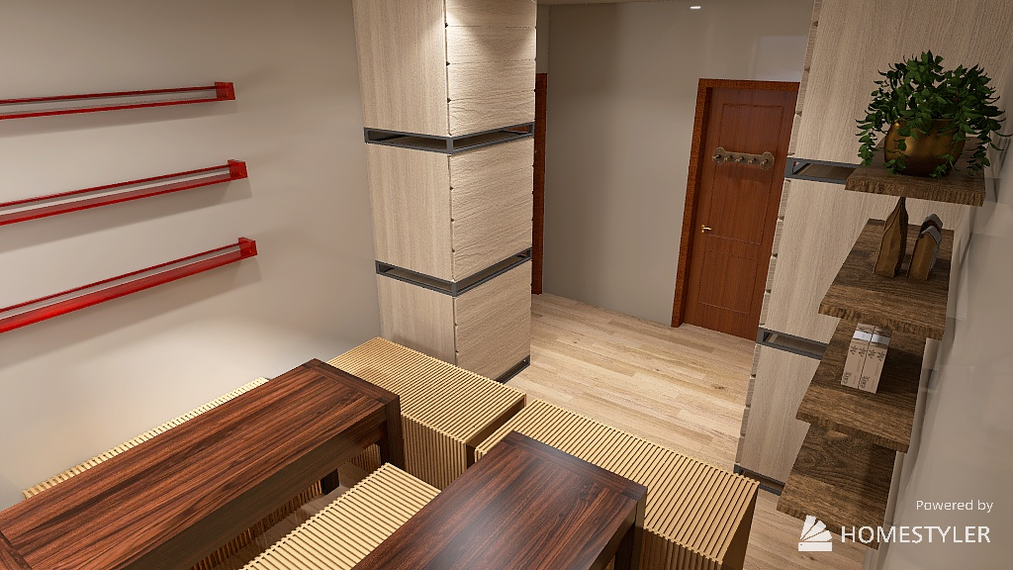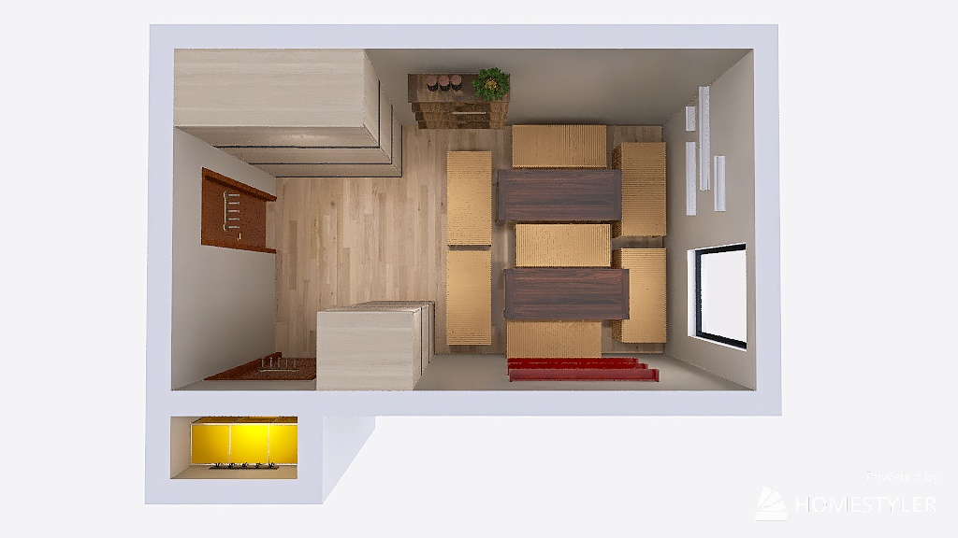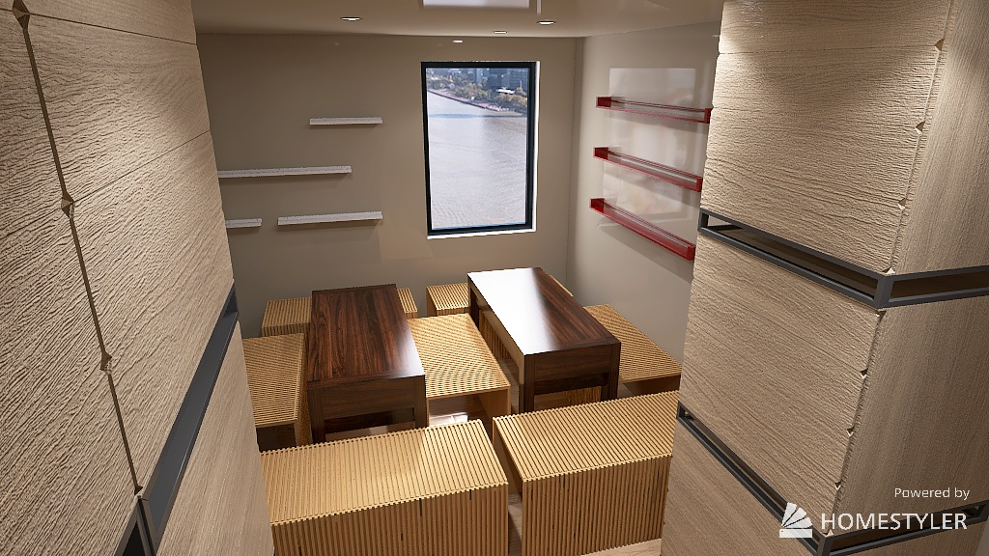

Figure 11. *Vertical space layout simulation in a Medium-sized club room made using Homestyler.*

Table 7. Objective Comparison of Aris.

|  |  |
| --- | --- |
| Objectives | Description |
| Maximize utilization of space | As for a medium-sized club room, this space can fit well between 7-13 students by seating. |
| Adaptable Furniture | Furniture in this room contains an extra functionality of space-efficiency through its ability to shrink. |
| Minimize cost | Total budget cost: ranges from $5700- $6200 [Appendix O.] which is under budget. |
| Durable and robust | Sold furniture and storage items must be built to be durable by the Sale of Goods Act [22]. |
| Secure | Color-coded systems and hung storage systems have lock systems however stacked storage drawers do not. |

### 

### 

### *6.3.2 Design #2* - Drawer Storages: “Pandora”

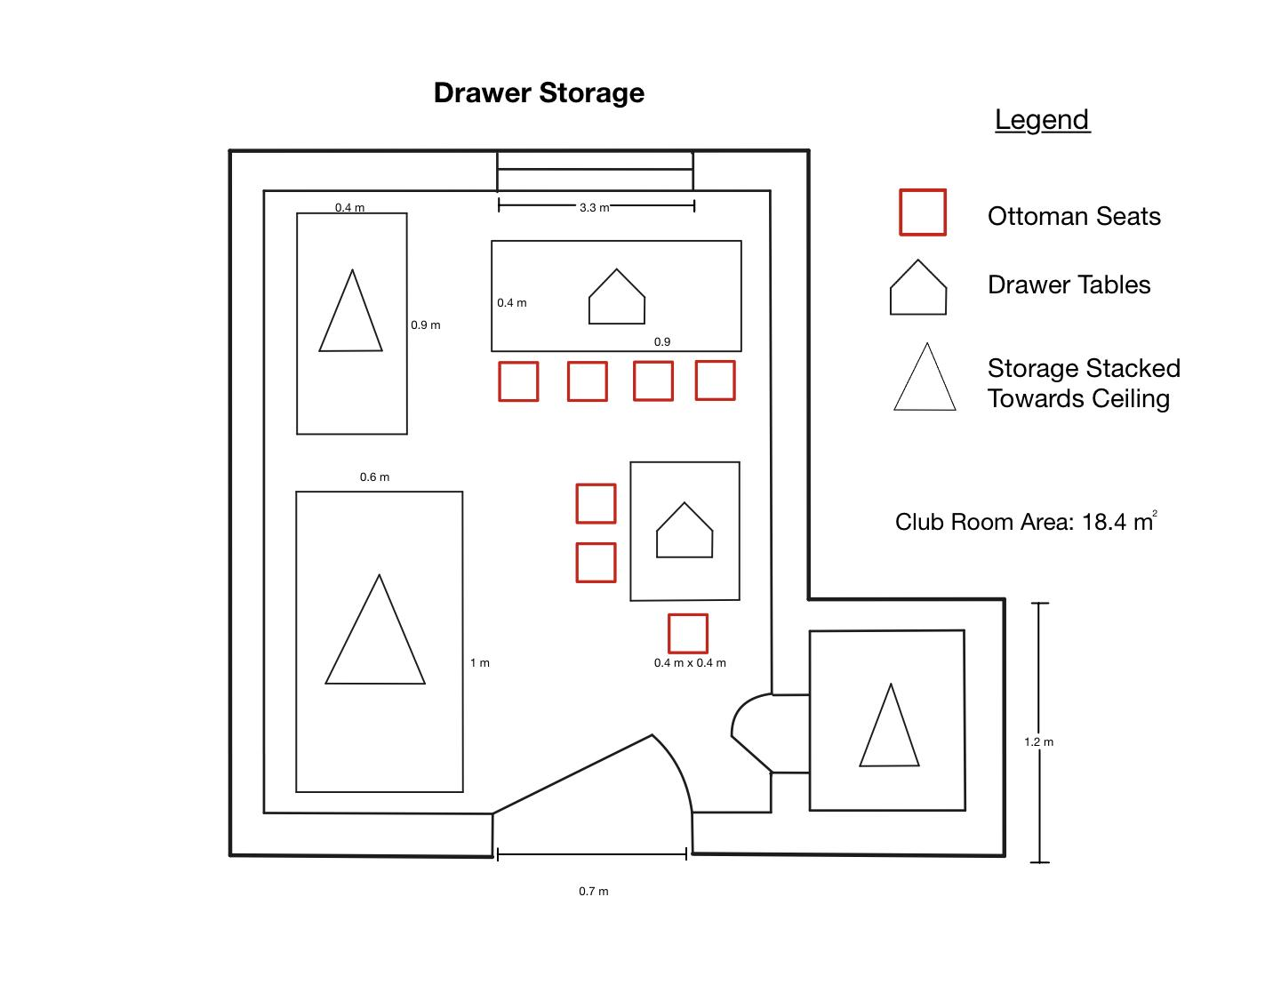

Figure 12. *Drawer Storage solution blueprint incorporated into room 505 of the clubhouse.*

Pandora, the drawer storage solution, uses drawers as a club room storage solution. The solution includes: drawer dividers that divide items by ranging sizes in drawers, tables with drawers, ottoman seats for storage underneath and the placement of items to surround people to avoid obstruction hazards.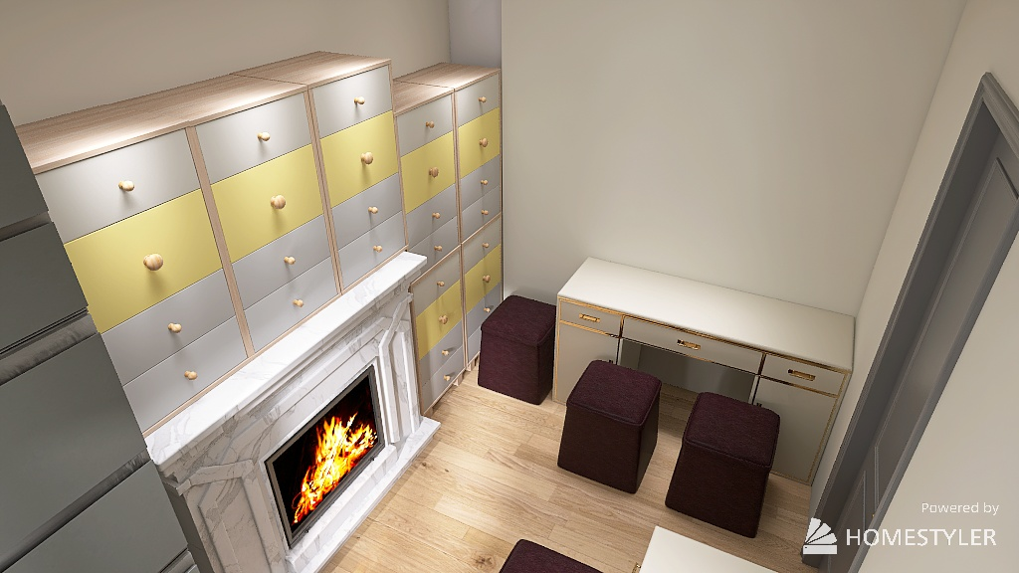

# 

# Figure 13. *Drawer storage layout simulation in a small-sized club room made in Homestyler.*

Table 8. Objective Comparison of Pandora.

|  |  |
| --- | --- |
| Objectives | Description |
| Maximize utilization of space | This design can fit 1-6 students by seating in a small-sized room. |
| Adaptable Furniture | Furniture in this room provides storage space underneath seats and drawers. |
| Minimize cost | Total budget cost: $3200-$7000 [Appendix O] which is under budget. |
| Durable and robust | Sold furniture and storage items must be built to be durable by the Sale of Goods Act [22]. |
| Secure | Ottoman seats and drawers are without a lock system. Does not pass this objective |

### *6.3.3 Design #3* - Adaptable Furniture: “Proteus”

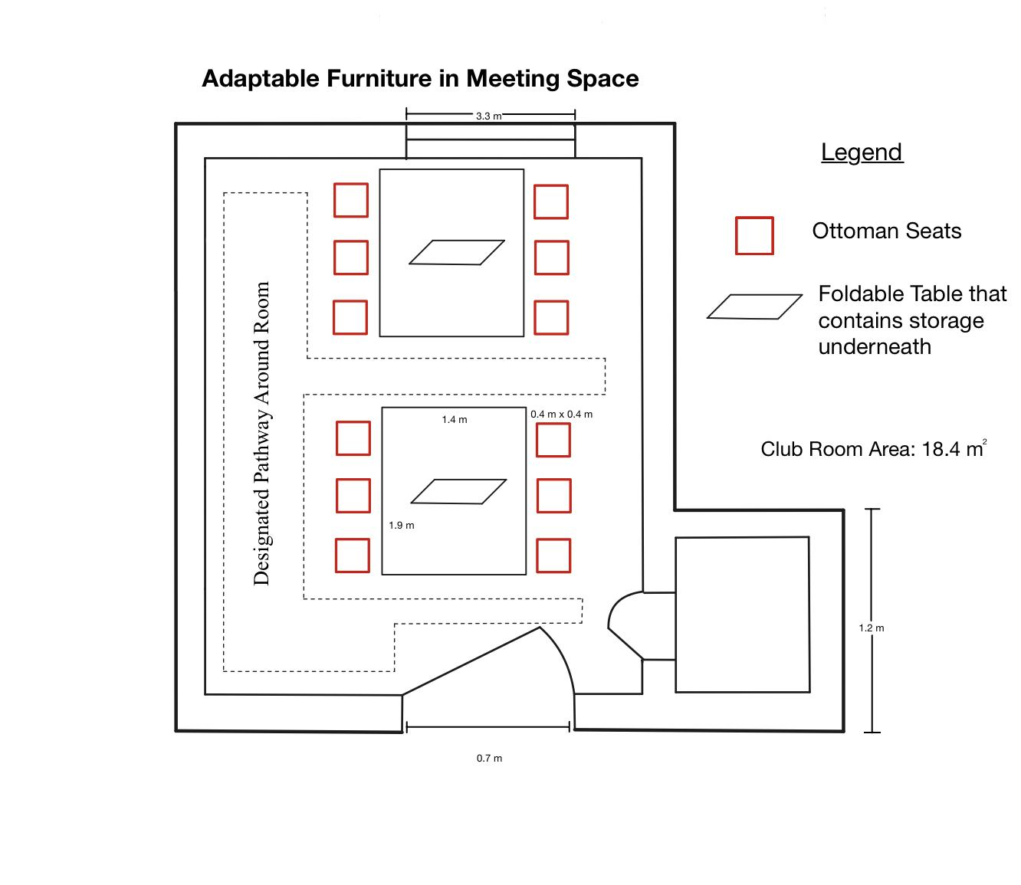

Figure 14. *Adaptable Furniture solution blueprint incorporated into room 505*

Proteus, the adaptable furniture storage solution, uses versatile furniture to attend to club’s needs while having the storage capability. The solution includes ottoman seats and a table with storage underneath, and an established designated pathway around the room that should not be stored with items.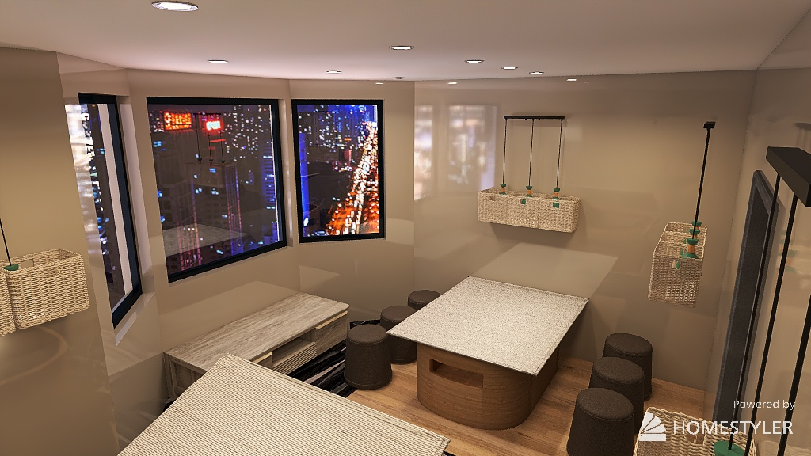

# 

# Figure 15. *Adaptable furniture layout simulation in a big-sized club room made in Homestyler.*

Table 9. Objective Comparison of Proteus.

|  |  |
| --- | --- |
| Objectives | Description |
| Maximize utilization of space | This space can fit 14-20 students by seating in a big-sized room. |
| Adaptable Furniture | Furniture in this room provides storage spaces underneath seats and storage in tables. |
| Minimize cost | Total budget cost: about $2200 [Appendix O] which is below budget. |
| Durable and robust | Sold furniture and storage items must be built to be durable by the Sale of Goods Act [22]. |
| Secure | Tables with storage can have a lock system.  Ottoman seats do not have a lock system. |

# 

# 7.0 Proposed Conceptual Design

To determine which design to recommend to the Client, we have implemented the Pugh method to select the final 3 ideas. “Space Saving Home Office” idea, which included Stairs that lead to higher storage + Nesting Cabinets inside walls + Wall-Mounted Drop Leaf Table + Ottoman seats (storage under the seat), was used as a baseline for the solution comparison. This section presents why the team chose the given design.

Table 10. *Pugh Method Chart*

|  |  |  |  |  |  |  |
| --- | --- | --- | --- | --- | --- | --- |
| Base Idea:  Space-Saving Home Office | Stairs that lead to higher storage + Nesting Cabinets inside walls + Wall-Mounted Drop Leaf Table + Ottoman seats (storage under the seat) | | | | | |
|  | Maximize utilization of space | Adaptable Furniture | Minimize cost | Durable and robust | Secure | Total score |
| Space-Saving Home Office | 0 | 0 | 0 | 0 | 0 | 0 |
| Vertical space | 2 | 1 | 0 | 1 | 1 | 5 |
| Drawer Storages | 1 | -1 | 1 | 1 | 1 | 3 |
| Adaptable furniture in meeting space | 1 | 2 | 0 | -1 | -1 | 1 |

After reviewing the results of the Pugh chart, our team has concluded that Design #1: Vertical Space, which focuses on maximizing vertical space utilization, best fits the clients needs. This design allows for the space to be utilized for more club meetings and provides adequate room for storage. Mindful of client constraints [3] as well as Ontario building codes [5] , this design will revitalize the Clubhouse by encouraging collaboration and team creativity through creating more floor space for club members and increasing versatile storage to place on the walls. This idea is also in line with the objectives as it is durable and robust using racks, shelves and hooks to increase storage options.This design focuses on maximizing floor space in order to bring more people into the clubhouse, allowing for a revival of the original functions of the clubhouse. The design as a whole is flexible and can be adapted to fit each club's needs and changing requirements.

# 

# 

# 

# 

# 8.0 Measures Of Success

To establish whether or not the suggested solution will cater to the client’s needs, success metrics must be defined. This section suggests a viable test plan that can be completed in no more than four weeks to support the suggested design proposal.

The results of this series of tests will provide us with a sufficient assessment of the success of the storage space redesign as an evaluation of a space's strengths, as well as its intended and actual uses being measured which is viable according to LinkedIn [27].

Scaled models of our “Vertical Space” proposed conceptual design will be presented to the client in the third client meeting. This will visualize the design plan, ensuring the incorporation of designs into each club room. A model will be created to represent possible implementations in the storage room and a medium sized club room within the Sussex clubhouse.

To test the “livelihood” in the clubrooms, Margaret Chen will send a survey [Appendix O] to the club occupying the room for redesign, which will be conducted 4 weeks after the redesign is implemented. We will measure how successful our design is based on the club users' feedback.

We have also sent out a survey collecting feedback on how clubs feel about the current usage of space in the clubhouse. This can add additional support when comparing the “before” and “after” of implementing our design. Dora Lyu will collect all of the data via Google Survey 4 weeks after the survey has been sent out.

Matthew Ting and Anjali Jammulamadaka will calculate the additional space after the implementation of the design which will provide a quantitative indication on the success of the space objective.

Lydia Messiha and Chris Yip will calculate the additional storage after the implementation of the design which will provide a quantitative indication on the success of the storage objective. One week after the redesign is implemented, the final comparison tests will take place, this is to account for possible maneuvering of the redesign’s layout.

# 

# 

# 

# 9.0 Conclusion

The comprehensive review of the Sussex Clubhouse Space Audit has led to the identification of the issues at the Sussex Clubhouse and three alternate solutions. Through rigorous evaluation, the Aris Vertical Space solution is deemed the most feasible in terms of its maximization of space, versatility, durability, cost, and security. The team is now ready to present this design and test plan to gain valuable feedback from the client. This will help us validate the efficacy of the chosen design before its full-scale implementation.

# 10.0 Citations

[1] "Contact Us." St. George Campus Safety. <https://www.campussafety.utoronto.ca/contact-us> (Accessed Feb. 29, 2024).

[2] T. Cardoso. "Contact." The Varsity. <https://thevarsity.ca/contact/> (Accessed Feb. 29, 2024).

[3] A. Ahmed et al., “TUT0114 Team 095 First Client Meeting,” February 5, 2024

[4] "Sussex Court." Architectural Conservancy Ontario. <https://www.acotoronto.ca/building.php?ID=6617> (Accessed Feb. 28, 202

[5] Ontario Building Code, O Reg. 332/12 s.3.1.17(1)

[6] "Connect." Campus Wireless. <https://wireless.utoronto.ca/connect/> (Accessed Feb. 28, 2024)

[7] "Institutional Equity Office." University of Toronto. <https://people.utoronto.ca/inclusion/institutional-equity-office/> (Accessed Feb. 28, 2024).

[8] Toronto Municipal Codes Chapter 629 Property Standards, <https://www.toronto.ca/wp-content/uploads/2017/08/9027-1184_629.pdf> (accessed Feb 28, 2024).

[9] "Noise at Work." Environmental Health and Safety. <https://ehs.utoronto.ca/wp-content/uploads/2022/06/Noise-at-Work-Understanding-the-Difference-Between-Hazardous-and-Nuisance-Noise.pdf> (Accessed Feb. 28, 2024).

[10] Think Interior, “Furniture Arrangement: Strategies for Optimal Use of Space and Comfort,” Accessed: February 16, 2023. [Online]. Available: <https://academythinkinteriordesign.medium.com/furniture-arrangement-strategies-for-optimal-use-of-space-and-comfort-29b687cc5eca>

[11] "Universal Storage." Steelcase. <https://www.steelcase.com/products/systems-storage/universal-storage/> (Accessed Feb. 28, 2024).

[12] J. Bastian. "Revving Up Health & Safety in Schools Through Deep Cleaning." CloroxPro. <https://www.cloroxpro.com/blog/revving-up-health-safety-in-schools-through-deep-cleaning/> (Accessed Feb. 28, 2024).

[13] "Incident and Accident Reporting." Insurance Bureau of Canada. <https://www.ibc.ca/stay-protected/protect-your-business/incident-and-accident-reporting> (Accessed Feb. 28, 2024).

[14] "How to Report a Security Incident?" Shergroup. <https://shergroup.com/post/security-incident-reporting/#:~:text=A%20security%20incident%20report%20is,like%20theft%20and%20criminal%20attacks> (Accessed Feb. 28, 2024).

[15] "How to Calculate Warehouse Space Utilization." Camcode. <https://www.camcode.com/blog/how-to-calculate-warehouse-space-utilization/> (Accessed Feb. 28, 2024).

[16] Engineering Notebook Notes

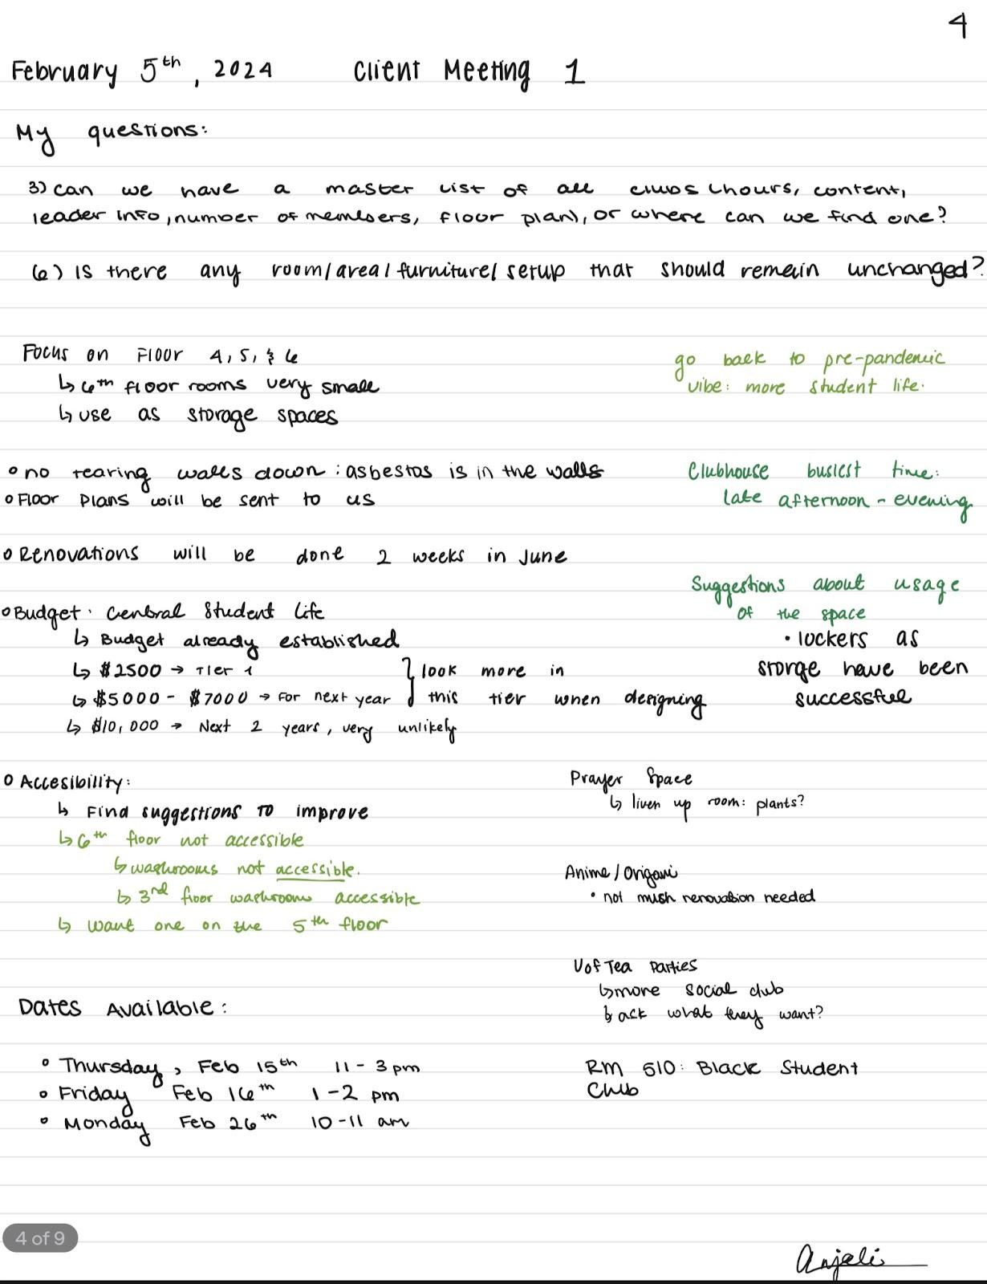

[17] I. & C. Designs, “Smart hidden furniture and space saving design solutions for Small Apartments,” YouTube, https://youtu.be/ZMV4l6sqteM?si=_wJu-pPXsZizJG8B (accessed Mar. 24, 2024).

[18] Aliexpress. “Creative Paper Stool Fashion Telescopic Bench Folding Portable Space-saving Low Multi-functional Entrance Door Changing Shoe.” Accessed: March 24, 2024. [Online]. Available. <https://www.aliexpress.com/item/1005003904768434.html>

[19] Uline. “Metro Storage Cabinet - 2-Shelf, Walnut.” Accessed: March 24, 2024. [Online]. Available. <https://www.uline.ca/Product/Detail/H-10295/Office-Storage/Metro-Storage-Cabinet-2-Shelf-Walnut>

[20] Uline. “Bathroom Shelf - 12 x 5 x 4".” Accessed: March 24, 2024. [Online]. Available. <https://www.uline.ca/Product/Detail/H-9521/Bathroom-Supplies/Bathroom-Shelf-12-x-5-x-4?pricode=YM650&gadtype=pla&id=H-9521&gad_source=1&gclid=CjwKCAjwnv-vBhBdEiwABCYQAz4o9ZWMX1EjfkJ-yJm7RhLrAwW7qfOHjsLXQsi1TEXu5nyfme5XvxoCqDQQAvD_BwE>

[21] Wayfair. “Ahlayla Coffee Table.” Accessed: March 24, 2024. [Online]. Available. <https://www.wayfair.ca/Millwood-Pines--Solid-Wood-Rustic-Coffee-Table-X211115717-L441-K~C100004650.html>?

[22] Accessed: March 24, 2024. [Online]. Available.

<https://wiki.clicklaw.bc.ca/index.php?title=Sale_of_Goods_Law#The_goods_are_reasonably_durable>

[23] Uline. “4 Drawer/4 Drawer Pedestal Workbench - 60 x 30", Composite Wood Top.” Accessed: March 24, 2024. [Online]. Available. <https://www.uline.ca/Product/Detail/H-2171-WOOD/Pedestal-Workbenches/4-Drawer-4-Drawer-Pedestal-Workbench-60-x-30-Composite-Wood-Top?pricode=YG086&gadtype=pla&id=H-2171-WOOD&gad_source=1&gclid=CjwKCAjwnv-vBhBdEiwABCYQA4kxIXQsR2gQFT07UinnBC-FX97CbvLIfJA3SHv6VhGURAR67jWtDBoCgK8QAvD_BwE>

[24] The Furniture Depot. “Mariana Storage Ottoman.” Accessed: March 24, 2024. [Online]. Available: <https://furnituredepot.ca/products/mariana-storage-ottoman>

[25] Oak and Sofa Liquidators. “Homelegance Lift Top Coffee Table With Faux Marble Top.” Accessed: March 24, 2024. [Online]. Available. <https://oakandsofaliquidators.com/products/lift-top-coffee-table-with-faux-marble-top_hm7916-30>

[26] Bouclair. “Water Hyacinth Basket.” Accessed: March 24, 2024. [Online]. Available. <https://www.bouclair.com/en/our-best-price/bed-and-bath/water-hyacinth-basket-9402490.html>?

<https://ayerssaintgross.com/work/space-analytics/space-assessment-and-analysis/> try this or this

[27] “What are the best practices for conducting a space audit and identifying security risks?” LinkedIn. Accessed: March 24, 2024. [Online] Available: <https://www.linkedin.com/advice/0/what-best-practices-conducting-space-audit-identifying#:~:text=A%20space%20audit%20is%20a,as%20its%20strengths%20and%20weaknesses>.

# 11.0 Appendix

## APPENDIX A. Myhal Center: Benchmarking - Margaret & Dora

Benchmarking:Myhal Centre for Engineering Innovation and Entrepreneurship

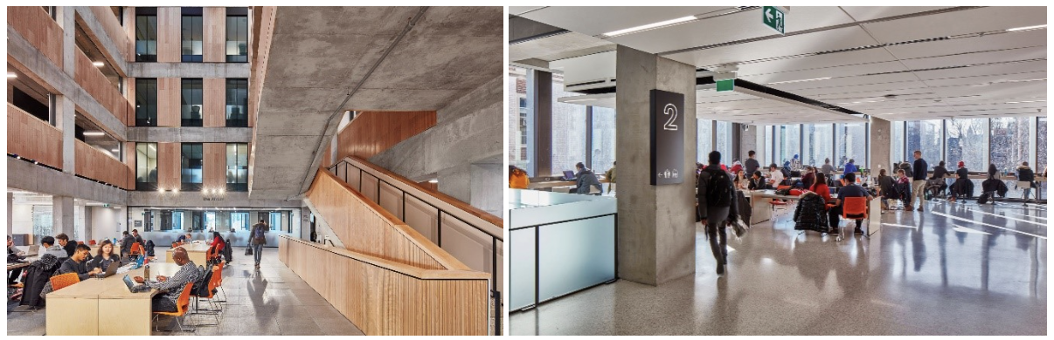

Figure 16. *Myhal Centre Collaborative Spaces(the fifth floor)*

The Myhal Centre is designed to enhance engineering education and research, fostering collaboration among students, researchers, and industry partners. The facility boasts state-of-the-art prototyping facilities, multidisciplinary research hubs, design studios, and technology-enhanced learning spaces. Its open and flexible spaces encourage interaction and innovation, setting a new standard for engineering education facilities.

Table 11. *Myhal Centre Storage Observation.*

|  |  |
| --- | --- |
| **Figure(s)** | **Description** |
| Figure 17. *Myhal lockers* | * The integration of lockers into the wall structure represents an intelligent design solution that significantly enhances space efficiency within the corridor. * The extensive deployment of numerous lockers ensures ample personal storage capacity. |
| Figure 18. *Storage area for Myhal* | * These are examples of underutilization of space. Lots of clutter piled up on the floor, while there is still plenty of free space on the shelves and desks. |
| Figure 19. *Storage area for Myhal* | * The storage room pictured here has a number of display shelves, organizers and bookcases to categorize the large amount of clutter in the storage room. * In addition to traditional ways of organizing, there is a use of tool wall organizers to save ground space. |

Table 12. *Pros and Cons of Myhal Centre Design*

|  |  |
| --- | --- |
| Pros | Cons |
| 1. Encourages collaboration through open spaces 2. Supports innovation with state-of-the-art facilities 3. Flexible design accommodates various activities 4. Multifunctional use for different areas | 1. High-tech features may increase operational costs 2. Open spaces might require more effective noise management strategies |

Table 13. *Space Objective Assessment.*

|  |  |
| --- | --- |
| **Space Objectives** | Goals and Description |
| Maximize utilization of space: | The design optimizes space for a variety of uses, from individual study to large collaborative projects. |
| Maximize utilization of space: | The flexible layout can easily be adjusted to meet the evolving requirements of users and technological advancements. |

Table 14. *Storage Objective Assessment.*

|  |  |
| --- | --- |
| **Storage Objectives** |  |
| **Innovative storage solutions:** | Utilizes smart storage solutions for equipment and materials, ensuring easy access without compromising space functionality |
|
|
|

The Myhal Centre for Engineering Innovation and Entrepreneurship represents a significant advancement in engineering education and collaborative research. By comparing it to other spaces like the Sussex Clubhouse, it's evident that the Myhal Centre's design prioritizes flexibility, innovation, and collaboration. Its state-of-the-art facilities and open spaces encourage interaction among students, researchers, and industry partners, setting a new benchmark for academic and research institutions. The Myhal Centre's approach to maximizing space utilization and fostering an environment conducive to innovation offers valuable insights for enhancing our design‘s multi functionality and user experience.

## APPENDIX B. Gerstein Library: Benchmarking - Written by Matthew

Benchmarking: Gerstein Library



Figure 20. Gerstein Library Bookshelves stacked to the ceiling

Gerstein Library is a student space to study and read. Students will go to Gerstein for a general quiet space on campus. Books and documents are stored along the shelves with hallways that help users easily access each row. Unlike the Sussex Clubhouse, the library has a bigger area and height for storage options but provides a helpful component to our brainstorming process. Books are stacked to the ceiling which allows for less shelves to interfere with the accessible walking space.

Table 15. *Gerstein Library Measurements.*

|  |  |  |
| --- | --- | --- |
| Bookshelf Height: 2.28m | Bookshelf Width: 0.38m | Bookshelf Length: 14.25m |
| Height of Library of Figure X: 2.52m | Width of walkway: 0.7125m | Time it takes to move around the and cover 4.75m x 2.25m of storage space: 6.72s |

Our final solution should incorporate this solution as rearranging storage for better walkspace considers two major functions: the solution component gives a better storage option while helping people walking around the space in a more efficient way.

Although this solution is present in Gerstein Library, it is good to give a good assessment on the solution and how well it can be incorporated into our solution.

Table 16. *Pros and Cons of Gernstein Library solution.*

|  |  |
| --- | --- |
| Pros | Cons |
| * Very accessible through hallways that can go through each piece of storage * Each piece of storage is visible * Better use of volume of the room | * Hallways are narrow * As each shelf is stacked to the ceiling, their is less space for wall design * Storage might be a bit harder to access with items stored at a more elevated level |

Table 17. *Space Objective Assessment.*

|  |  |
| --- | --- |
| Space Objectives | Goals and Description |
| Maximize utilization of space | As this solution is more fitted as a storage improvement, this solution improves the storage space which leaves other rooms emptier for space that students can use, improving the area of space students can use. |
| Adaptable furniture | As more space is freed from a storage improvement, there is more space to move around furniture for different activities |

Table 18*. Storage Objective Assessment.*

|  |  |
| --- | --- |
| Storage Objectives | Goals and Description |
| Durable and Robust | Rearrangement of the cabinets will not affect the material that crafted the cabinet |
| Secure | Rearranging cabinets does not change the security of the cabinet. |
| Flexible | Cabinets have a volumetric storage space which allows for storage of all sizes. |
| Minimize cost | This does minimize cost as the storage room already includes storage cabinets that can be rearranged. This would require minimal to no cost as this solution only rearranges the storage space. |

In conclusion, the Gerstein Library has provided a significant contribution to the storage issue as in contrast to the library, the clubhouse does not maximize the elevated areas of each room which can be used for storage. There is a big difference between the areas that people can walk through but an investigation on a similarly-purposed space helps the process for finding a solution to the Sussex Clubhouse Space.

## APPENDIX C. Dry Cleaner: Benchmarking - Written by Dora & Matthew

Benchmarking: Dry Cleaner

A dry cleaner layout is usually designed to optimize employee productivity and space use efficiency through planning the arrangement of equipment and the flow of work. In this situation, the use of automated transmission machines is adapted to transport, sort, and store garments.

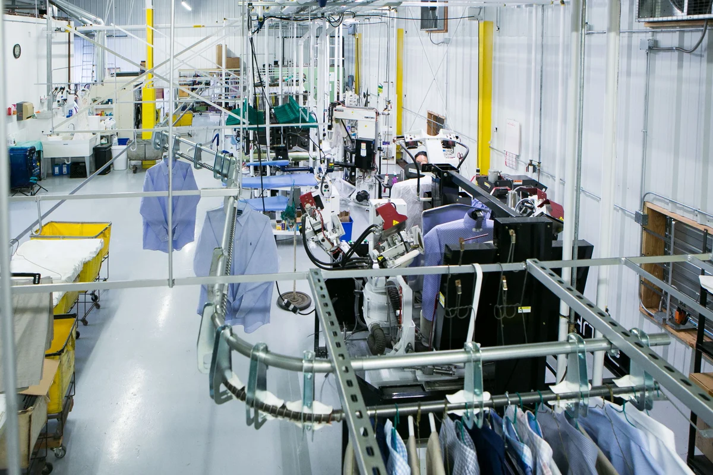

Figure 21. Display of clothes on rack of dry cleaning system

Solution

Automated Transmission Machine (Automated Garment Conveyor System)

Description

This system consists of a motorized conveyor track equipped with hooks or slots where garments can be hung and automatically moved to different stations for processing or storage.This technology allows dry cleaners to manage a great amount of clothing items in an orderly and efficient manner.

Table 17. *Pros and Cons of Dry Cleaner solution.*

|  |  |
| --- | --- |
| Pros | Cons |
| * Saves space from the remove of the need to walk around through each cabinet * Easily access any storage unit through the hold of a button | * Could be costly due to springs and levers that require metal parts * Requires mechanical energy to operate * Requires regular maintenance updates and check ups |

Table 18. *Space Objective Assessment.*

|  |  |
| --- | --- |
| **Space Objectives** | Goals and Description |
| Maximize utilization of space | Saves walking space in storage room as system uses rotational space |
| Adaptable furniture | This solution is to be incorporated into the storage room directly |

Table 19*. Storage Objective Assessment.*

|  |  |
| --- | --- |
| **Storage Objectives** | Goals and Description |
| Durable and Robust | The material of this transmission system should be stiff enough and requires constant maintenance. |
| Secure | These cabinets are stored so close to each other that it is impossible to open until withdrawn from the machine, the button to cycle cabinets will have a lock |
| Flexible | Users get easy access to specific clothing wherever it is stored with the automatic transmission system |

Conclusion (comparison)

The use of Automated Transmission System in a Dry Cleaner aims to optimize the utilization of limited space and increase efficiency in retrieving items, which is exactly the same need for the Clubhouse redesign. But this system requires a high building cost and is probably still too large for the storage room size provided in Clubhouse.

## APPENDIX D. Hart House: Benchmarking - Written by Lydia & Anjali

Benchmarking: Hart House

Hart House is a student-focused center that houses many different expressions of student arts, wellness, and dialogue. Hart House allows unique ways for students, faculty, alumni and the broader community to connect and engage with one another. The facility includes a wide range of rooms for studying, dining, recreation,and socializing.

Despite their being small meeting rooms in Hart House, they are designed in a way that fosters community between students, creating a lively environment.

*Table 1: Pros and Cons of Hart House*

|  |  |
| --- | --- |
| Pros | Cons |
| * has many different rooms and allows for a wide variety of student groups to meet and collaborate * Room sizes vary allowing for small meeting and studying rooms (5-10) and large rooms that allow for 30-50 people * Allow for storage of different materials like sporting equipment, food, instruments, books, etc. | * the building is slightly disorganized which can allow for clutter with no systematic process of where things need to be placed * there is not overall community within Hart House and more separate small communities that come in and out each day * It can be difficult to navigate Hart House and understand where everything is and where certain rooms with specific functions are. |

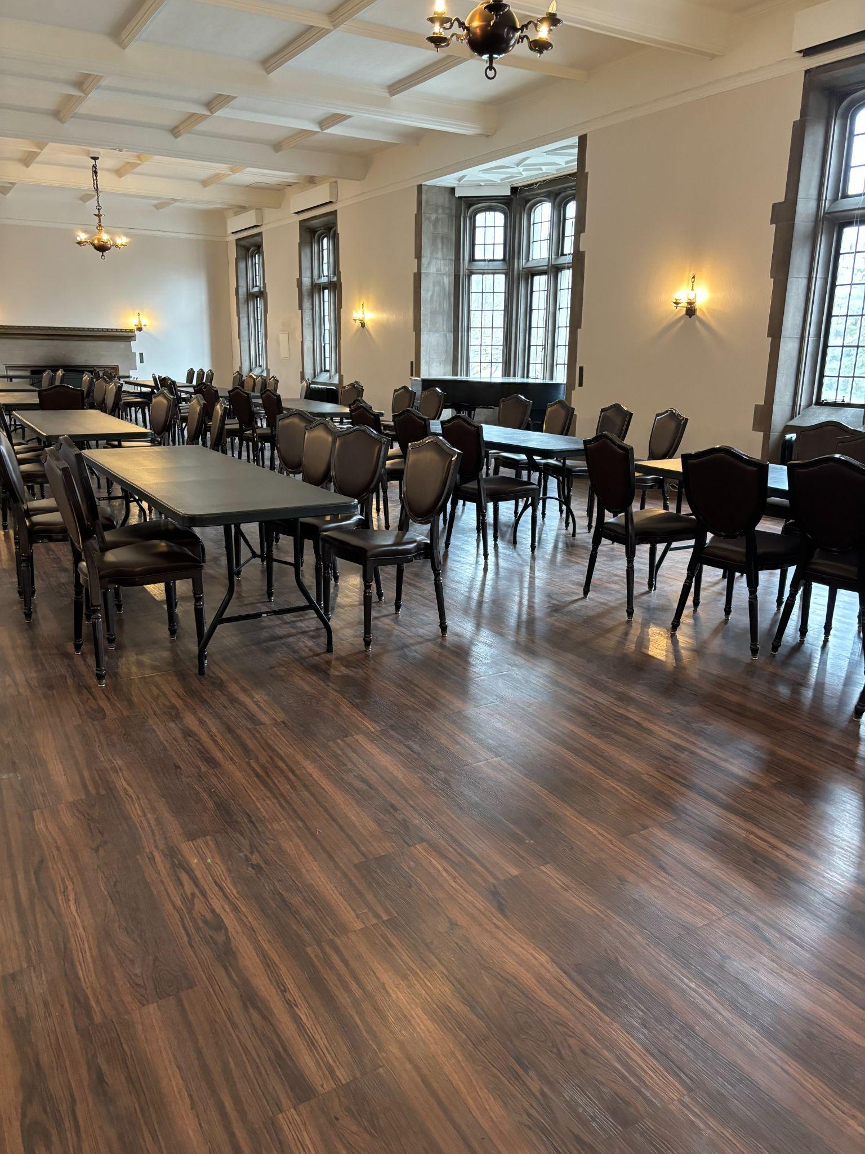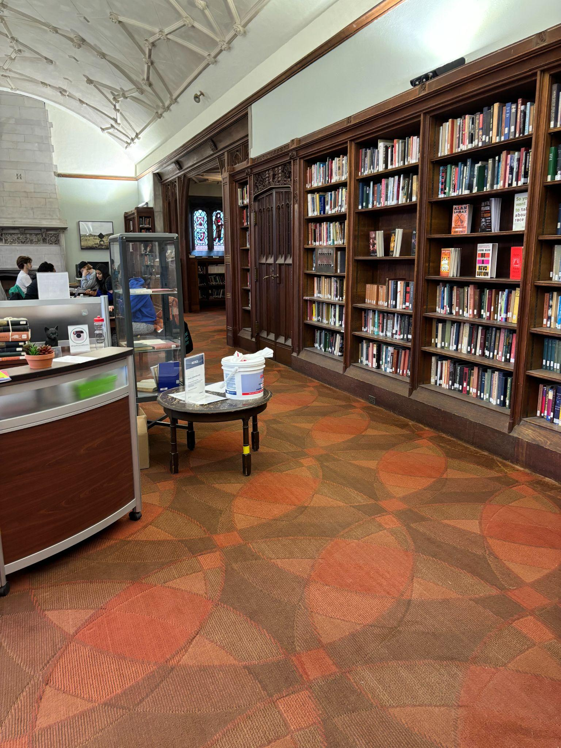

Figure 22. Rooms in Hart House

*Table 2: Space Objectives of Hart House*

|  |  |
| --- | --- |
| Space Objectives | Description |
| Maximize utilization of the space | Various spaces within Hart House hold student gatherings to foster community, collaboration and creativity. The goal is to have a building that brings people together. Rooms are organized, creating space for students and faculty to gather properly without having any obstacles such as misplaced items, etc. |
| Universal Usage of Furniture | Hart house utilizes many different furniture options, making it easy to cater a room to your needs. They have foldable chairs and tables as well as chairs and tables with wheels that can move to however the user likes. |

*Table 3: Storage Objectives of Hart House*

|  |  |
| --- | --- |
| Storage Objectives | Description |
| Secure | Hart House has storage cabinets that are locked up so no one without a key can access what's inside. |
| Durable and robust | Hart House has storage for all different types of materials, such as sports equipment, books, important documents, and even food. They are equipped to store all different types of materials well. |

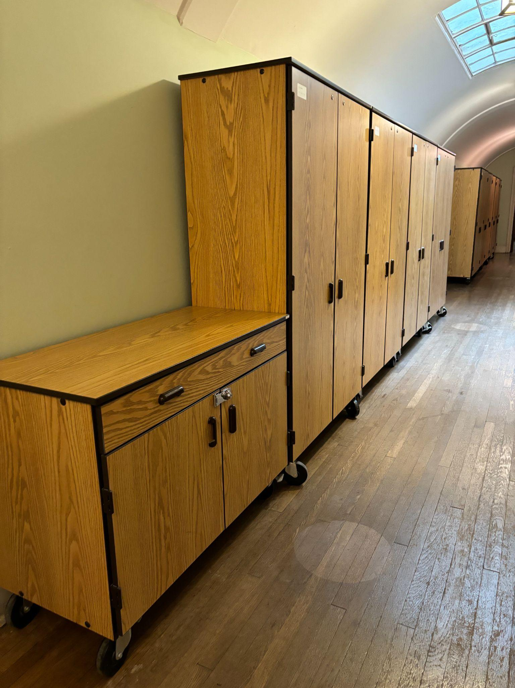

Figure 23. Cabinets and Storage in Hart House.

Function: Provide free meeting and work spaces for clubs and the staff of the University of Toronto and bring more students into the clubhouse and construct a more lively space.

*Table 4*

|  |  |
| --- | --- |
| Form | Flow |
| The Hart House meeting rooms, despite their size, provide an efficient and lively space for students to meet and socialize. Some rooms are large rooms for meetings while some are smaller. Hart House is equipped with various types of storage units. | Mass: UofT Students and Staff in and out. Items in and out of storage units.  Energy: Lighting  Information: Student/staff meetings |
| Analysis: There are durable and spacious storage units in place as shown in Figure 2. They are portable since they are equipped with wheels. The storage units are sturdy as they are made of wood. The units are spacious and can store a significant amount of items. | |

Hart House is an excellent example of the environment the client wants to recreate at the Clubhouse. A friendly environment that fosters collaboration, creativity, and group work through the utilization of large meeting spaces with adequate storage, as well as smaller meeting rooms for more intimate meetings. Hart House has many different types of storage units as well, and there is always somewhere to gather people, be on your own, or store important material.

## 

## APPENDIX E. SCAMPER Table

Table X. *SCAMPER table that used the SCAMPER method to generate ideas based off of the designed problem. Additional brainstormed ideas were added here.*

|  |  |  |  |
| --- | --- | --- | --- |
| **Storing efficiently** | | **Space efficiency: Adaptable Furniture** | **Mobility: Transportation around the room** |
| **Storage room** | **Storage for club room** |
| Bigger Cabinets | Storage under foldable couch | Foldable Tables/Desks | Designated pathways around the room |
| Renting a storage unit | Storage under box seats | Chairs that have wheels | Rearrange items to surround people |
| Incorporating baskets and large nets on the ceiling to hold material | Storage in vertical space:racks or shelves | Chairs that are stackable and can fold | Divide room into work and storage place |
| Allowing for general storage + locked up storage | Reduce the one-time purchase of consumables | Ottoman-style seats (can hold items) | Limit amount of stuff allowed to be stored by each club in the rooms |
| Elevated storage units | Hanging organizer in the closet | Expandable chair |  |
| Stairs that lead to higher storage | Hooks on the doors | Lift top tables |  |
| Drawer Dividers | Include more desks with drawers | Shrinkable sofa with storage space |  |
| Stackable Bins | Tables or chairs with build-in drawers | Expandable shelves |  |
| Drawer+Stairs that lead to higher storage | Snacks store in the public kitchen | Lockers with insertable shelves |  |
| Underfloor Space | Disposable recyclable storage | Wall-Mounted Drop Leaf Table |  |
| Nesting cabinets inside walls | Rolling storage carts | Rotating Storage |  |
| Automated Transmission Storage Units | Stackable shelves | Fold-Down Wall Desks |  |
| Honeycomb Structure Cabinets | Minimum the size of furniture | Bed Risers |  |
| Sleeve Storage | Multi-Purpose Furniture | Centrepiece items are placed in center |  |
| Rip down all lockers and redesign | Bookcases with Doors | Use of all sides of furniture (e.g. table) |  |
| Implement a system for tracking and reporting facility maintenance issues | Build new storage units | Magnetic Levitation Furniture |  |
| Sustainable storage options, such as recycled materials or repurposed furniture. | removing table（meeting area） | nesting furniture |  |
| Implement a color-coded system for organizing storage areas based on group affiliation. | Second floor for storage | ceiling hung hammock chairs |  |
| Install lockers with built-in ventilation systems for storing athletic gear or uniforms. | Corner bench with hidden storage | Install privacy screens or dividers in  shared workspaces (2 club rooms) |  |
|  | Corner shelves | Floor seating pads |  |
|  | Host regular clean-up days to declutter shared spaces and optimize storage efficiency. | Puzzle seating |  |
|  | Offer incentives for groups to donate unused items to charity or recycling programs. | Shrinkable/collapsible furniture |  |
|  | Create a digital marketplace for buying, selling, or trading group resources and equipment. | smaller furniture |  |
|  | Underground storage |  |  |

## APPENDIX F. Idea list

Table X. *General idea list that was used to create the morph chart. These ideas were created in the brainstorming and benchmarking idea generation process.*

|  |  |  |  |  |
| --- | --- | --- | --- | --- |
|  | Idea | Description | Idea type | Idea Generator |
| Storage Room | Stack storage to ceiling | Storage cabinets are stored in a more  elevated area that is currently unused | SCAMPER  +Bench | Matthew |
|  | Dry Cleaning Garment Conveyor belt | Conveyer belt that holds storage cabinets  and rotates around the room | Bench | Matthew |
|  | Layered floor tiles | Additional layer that acts as walking space  that can also be used for cabinets | Brainstorming | Matthew |
|  | Item sort and filter | Item are stored in one big cabinet and are  scanned for each item name, item's are then  requested by machine and brought to user | Brainstorming | Matthew |
|  | Bigger Cabinets | Self-explanatory | Brainstorm  +SCAMPER | Chris |
|  | Renting a storage unit | Self-explanatory | Brainstorm  +SCAMPER | Matthew |
|  | Incorporating baskets and large nets on the ceiling to hold material | self explanatory | Brainstorm  +SCAMPER | Lydia |
|  | Allowing for general storage + locked up storage | if we allow for both general and locked up s  torage (which could be like a designated  room for all of the very special storage that is  not accessed as frequently) this can reduce  clutter | Brainstorm  + SCAMPER | Lydia |
|  | Elevated storage units | Cabinets and other storage units are used to  roof | SCAMPER  +Bench | Matthew |
|  | Stairs that lead to higher storage | Storage on ceiling with stairs that can access  (act as upper floor) | Brainstorm  +SCAMPER | Matthew |
|  | Drawer Dividers | Self-explanatory | Brainstorm  +SCAMPER | Chris |
|  | Implement a system for tracking and reporting facility maintenance issues | system could be digital for each room or a  physical form | Brainstorm  +SCAMPER | Lydia |
|  | Sustainable storage options, such as recycled materials or repurposed furniture. | this can help with cost as well as using what we already have | Brainstorm  +SCAMPER | Lydia |
|  | Implement a color-coded system for organizing storage areas based on group affiliation. | this can help with getting storage for different  types of things and will help us organize  different storage that we need to design  (heavy things vs sports vs paper, etc) | Brainstorm  +SCAMPER | Lydia |
|  | Install lockers with built-in ventilation systems for storing athletic gear or uniforms. | Self explanatory | Brainstorm  +SCAMPER | Lydia |
|  | Bookcases with Doors | Separate the items | Brainstorming | MC |
|  | Build new storage units | no explanation needed | Brainstorming | MC |
|  | removing table（meeting area） | no explanation needed | Brainstorming | MC |
|  | Second floor for storage | Add a partition above the room to hold items that can be climbed with a ladder | Brainstorming | Dora |
| Storage Club Room | Underfloor Space | higher the floor and add a  compartment under it, use the  compartment for storage | Brainstorming | Dora |
|  | Nesting cabinets inside walls | like what the Myhal basement did  for storage | Brainstorming | Dora |
|  | Automated Transmission Storage Units | a transmission belt can transmit  objects out from anywhere in the  cabinets | Brainstorming | Dora |
|  | Honeycomb Structure Cabinets | Honeycomb construction maximizes  weight capacity and make the  fullest use of space. | Brainstorming | Dora |
|  | Sleeve Storage | It's a sliding door design, when not  in use it can be set together,  when you need to use it can be  unfolded. See pictures posted in dc | Brainstorming | Dora |
|  | Storage under foldable couch | Self-explanatory | Brainstorm  +SCAMPER | Matthew |
|  | Ottoman-seats (storage under seat) | Self-explanatory | Brainstorm  +SCAMPER | Anjali |
|  | Storage in vertical space:racks or shelves | rack or shelves | Brainstorm  +SCAMPER | MC |
|  | Hanging organizer in the closet | no explanation needed | Brainstorm  +SCAMPER | MC |
|  | Hooks on the doors | no explanation needed | Brainstorm  +SCAMPER | MC |
|  | Include more desks with drawers | no explanation needed | Brainstorm  +SCAMPER | MC |
|  | Tables or chairs with build-in drawers | no explanation needed | Brainstorm  +SCAMPER | MC |
|  | Snacks store in the public kitchen | no explanation needed | Brainstorm  +SCAMPER | MC |
|  | Disposable recyclable storage | no explanation needed | Brainstorm  +SCAMPER | MC |
|  | Rolling storage carts | A rolling cart that store items that can be moved around | Brainstorm  +SCAMPER | MC |
|  | Stackable shelves | Shelves are stack to conserve floor space | Brainstorm  +SCAMPER | MC |
|  | Multi-Purpose Furniture | Furniture that used for different purposes | Brainstorm  +SCAMPER | MC |
|  | Corner bench with hidden storage | bench in the corner that can lift up to store items | Brainstorm  +SCAMPER | Anjali |
|  | Host regular clean-up days to declutter shared spaces and optimize storage efficiency. | description is self explanatory | Brainstorm  +SCAMPER | lydia |
|  | Offer incentives for groups to donate unused items to charity or recycling programs. | self explanatory | Brainstorm  +SCAMPER | lydia |
|  | Create a digital marketplace for buying, selling, or trading group resources and equipment. | self explanatory | Brainstorm  +SCAMPER | lydia |
| Space Efficiency | Trash,donate or take home items that  are unused | Solution is described in title | Brainstorming | Matthew |
|  | Centerpiece is placed in center | Any room items that are  generally used more  have centered furniture around  it | SCAMPER | Matthew |
|  | Use of all sides of furniture (e.g. table) | Some rooms have sides of  furniture that are unused that  can be used through furniture  arrangements | SCAMPER | Matthew |
|  | Magnetic levitation furniture | Use the principle of magnetic  levitation to make all the furniture in  the room floats in the air. Actually  kind of save in ground space and  increase its mobility. | Brainstorming | Dora |
|  | Foldable Tables/Desks | desks and chairs that can be folded and stored away for more space | Brainstorm  +SCAMPER | Anjali |
|  | Chairs that have wheels | Self-explanatory | Brainstorm  +SCAMPER |  |
|  | Chairs that are stackable and can fold | Self-explanatory | Brainstorm  +SCAMPER |  |
|  | Lift top tables | tables that lift to have more storage underneath | Brainstorm  +SCAMPER | Anjali |
|  | Shrinkable sofa with storage space | Self-explanatory | Brainstorm  +SCAMPER | Anjali |
|  | Lockers with insertable shelves | if clubs need more shelves they can insert them in their designated locker space | Brainstorm  +SCAMPER | Anjali |
|  | Wall-Mounted Drop Leaf Table | Self-explanatory | Brainstorm  +SCAMPER | MC |
|  | Fold-Down Wall Desks | Self-explanatory | Brainstorm  +SCAMPER |  |
|  | Bed Risers | Rises bed to have more space within the room | Brainstorm  +SCAMPER |  |
|  | Use of all sides of furniture (e.g. 4 sides of table) | Self-explanatory | Brainstorm  +SCAMPER | Matthew |
|  | nesting furniture | Self-explanatory | Brainstorm  +SCAMPER |  |
|  | ceiling hung hammock chairs | Self-explanatory | Brainstorm  +SCAMPER | Anjali |
|  | Install privacy screens or dividers in  shared workspaces (2 club rooms) | Self-explanatory | Brainstorm  +SCAMPER |  |
|  | Puzzle seating | Self-explanatory | Brainstorm  +SCAMPER | Anjali |
|  |  | Self-explanatory | Brainstorm  +SCAMPER | Anjali |
|  | Fold-Down Wall Desks | Desk set up on the wall and put it down when use it | brainstorm | MC |
|  | Install Locker accessories | Explore accessories such as hooks, bins, or  dividers that can be added to the inside of the  lockers to maximize storage capacity and  organization. These accessories can help  utilize the available space more effectively. | Brainstorm  +SCAMPER | Chris |
| Transport people | Designated pathways around the room | Pathways inscribed on the floor that  are not allowed to be used for storage | Brainstorm  +SCAMPER | Matthew |
|  |  | Items are occupied on walls, open space at  center for walking space | Brainstorm  +SCAMPER | Matthew |
|  | Limit amount of stuff allowed to be stored by each club in the rooms | Volume limit for storage | Brainstorm  +SCAMPER | Matthew |

* **Idea generation idea percentages (what percentage of ideas came from which idea generation methods)**
* **Score of ideas based on each idea generation method**
* **Feasibility chart votes**

## APPENDIX G. Multi-voting results

|  |  |
| --- | --- |
| Multi-voting results were derived from the morph chart selection | Below are the final ideas that remain after the multi-voting idea selection method |
| Storage furniture | Stack Storage to ceiling+Ottoman-Seats+Shrinkable furniture with storage space+Designated pathways around the room |
| Drawer storages | Drawer Dividers+Sleeve storage+Table/Chair with drawer+Rearrange items to surround people |
| Item removal | Allowing for general storage and locked up storage + Incentive to donate items+Item Marketplace + Limit items allowed to be stored |
| Room division | Bigger Cabinets+Racks and Shelves+Clean-Up days+Wall Mounted DropLeaf table+Divide room into work and storage place |
| Organization | Color-coded system+Honeycomb cabinets+Stack storage to ceiling+Foldable chairs+Designated pathways around the room |
| Use of elevated space | Stack Storage to ceiling+Honeycomb Cabinets+Shrinkable furniture with storage+Divide room into work and storage place |
| Outside storage | General storage and locked up storage+rent storage unit+storage carts+Take home unused items+Nesting furniture+Limit items allowed to be stored |
| vertical space | stack storage to the ceiling with elevated storage units, implement hanging organizers in closets and use hooks on doors and walls and use racks and shelves along the walls |
| compact furniture | foldable tables, collapsable chairs, chairs with wheels, stackable chairs, shrinkable sofas with storage space, sofas that can store chairs, tables that have space to put chairs under |
| maximize floor space | layered floor tiles, floor seating pads, puzzle seating for flexible arrangements, designated pathways around the room |
| maintenance and sustainability | implement a system for tracking facility maintenance, sustainable storage, disposable and recyclable storage, donate used items and offer incentives for clubs, digital marketplace, store food in public kitchen |
| innovation storage | automated transmission storage units, honeycomb structure cabinets, sleeve storage, storage under foldable couches, ceiling hung hammock chairs, implement bed risers |
| adaptable furniture in meeting space | Multi-Purpose Furniture + Foldable Tables/Desks + Ottoman-seats (storage under seat) + Incorporating baskets and large nets on the ceiling |
| meeting space storage | Tables or chairs with build-in drawers + Honeycomb Structure Cabinets + Sleeve Storage + Fold-Down Wall Desks |
| storage furniture | Wall-Mounted Drop Leaf Table + Remove table (meeting area) + Hanging organizer in the closet + Drawer Dividers |
| space saving | Tables or chairs with build-in drawers + Incorporating baskets and large nets on the ceiling + Fold-Down Wall Desks + Designated pathways around the room |
| Japanese minimalist model | Underfloor Space + Nesting cabinets inside walls + Bookcases with Doors +Corner bench with hidden storage + Install privacy screens or dividers in shared workspaces (2 club rooms |
| Workplace style (office) | Hanging organizer in the closet + Include more desks with drawers + Rolling storage carts + Multi-Purpose Furniture + Corner shelves + Host regular clean-up days to declutter shared spaces and optimize storage efficiency.+ Chairs that have wheels + Wall-Mounted Drop Leaf Table |
| Industrial style storage room | Install lockers with built-in ventilation systems for storing athletic gear or uniforms. + Automated Transmission Storage Units + Host regular clean-up days to declutter shared spaces and optimize storage efficiency. + Sleeve Storage |
| In huge storage needs | Storage in vertical space:racks or shelves + Hanging organizer in the closet + Hooks on the doors + Multi-Purpose Furniture Corner bench with hidden storage+ Host regular clean-up days to declutter shared spaces and optimize storage efficiency.+ Expandable shelves Wall-Mounted Drop Leaf Table |
| Social gathering room | Foldable Tables/Desk + Ottoman-style seats (can hold items) + Shrinkable sofa with storage spaceWall + Rearrange items to surround people+ Mounted Drop Leaf Table |
| Efficient Office | Automated Transmission Storage Units + Honeycomb Structure Cabinets + Foldable Tables/Desks + Bed Risers |
| Active Learning Classroom | Ottoman-seats (storage under seat) + Multi-Purpose Furniture + Ceiling Hung Hammock Chairs |
| Collaborative Tech Lounge | Automated Transmission Storage Units + Foldable Tables/Desks + Wall-Mounted Drop Leaf Table |
| Active Break Room | Ottoman-seats (storage under seat) + Honeycomb Structure Cabinets + Puzzle Seating + Hanging Organizer in the Closet |
| Space-Saving Home Office | Stairs that lead to higher storage + Nesting Cabinets inside walls + Wall-Mounted Drop Leaf Table + Ottoman-seats (storage under seat) |
| Elevated Storage | Elevated storage units+Ottoman-seats (storage under seat)+Limit amount of stuff allowed to be stored by each club in the rooms |
| Green Lounge | Drawer Divider+Sustainable storage options, such as recycled materials or repurposed furniture+Rearrange items to surround people |
| Secret Storage | Bookcases with Doors+Bed Risers+Designated pathways around the room |
| Easy Style Lounge | Drawer Dividers+Hanging organizer in the closet +Limit amount of stuff allowed to be stored by each club in the rooms |

## APPENDIX H. Graphical Decision Chart

Table X. *Graphical Decision Chart to assess ideas based off of our categorized objectives: storage and space*

|  |  |  |  |
| --- | --- | --- | --- |
| Storage Vs. Space | Removed 15 ideas that were below 0 axis | Graphical Decision Chart rank ranges: 5 from [-2.5,2.5] | These ideas either fit storage but not space, space but not storage or neither |
|  |  | Storage | Space |
| Storage furniture |  | 2 | 0 |
| Drawer storages |  | 0.5 | 2 |
| Item removal |  | 0 | 1.3 |
| Room division |  | 0.6 | 0 |
| Organization |  | 1.3 | 0.8 |
| Use of elevated space |  | 2 | 0.6 |
| Outside storage |  | 0.3 | -0.3 |
| vertical space |  | 2.3 | 2.1 |
| compact furniture |  | 0.7 | 1.3 |
| maximize floor space |  | -0.8 | 1.4 |
| maintenance and sustainability |  | -1.2 | -0.7 |
| innovation storage |  | 1.2 | -0.7 |
| adaptable furniture in meeting space |  | 1.3 | 0.3 |
| meeting space storage |  | 2.3 | 0.4 |
| storage furniture |  | -0.4 | 0.8 |
| space saving |  | 0.9 | -0.5 |
| Japanese minimalist model |  | 2.2 | -0.7 |
| Workplace style (office) |  | 2.1 | 0.7 |
| Industrial style storage room |  | 1.3 | -1.1 |
| In huge storage needs |  | 1.2 | 0.3 |
| Social gathering room |  | -1.3 | 2.2 |
| Efficient Office |  | -0.6 | 0.3 |
| Active Learning Classroom |  | 0 | -0.2 |
| Collaborative Tech Lounge |  | -0.6 | 0.4 |
| Active Break Room |  | 0 | 0 |
| Space-Saving Home Office |  | 0.7 | 0 |
| Elevated Storage |  | 1.3 | 0.5 |
| Green Lounge |  | 0.7 | -1.5 |
| Secret Storage |  | 0.4 | -2 |
| Easy Style Lounge |  | 1.7 | 1.9 |

## Appendix I Objective Pairwise Comparison Chart

Appendix E showcases a pairwise comparison chart between each objective to rank each objective by importance.

Table 11. *Space Objective Pairwise Comparison Chart*

|  |  |  |  |  |  |
| --- | --- | --- | --- | --- | --- |
|  | Maximize utilization of space | Adaptable Furniture | Minimize cost | Durable and robust | Total |
| Maximize utilization of space |  | 1 | 1 | 1 | 3 |
| Adaptable Furniture | 0 |  | 1 | 1 | 2 |
| Minimize cost | 0 | 0 |  | 0 | 0 |
| Durable and robust | 0 | 0 | 1 |  | 1 |

Table 12*: Storage Objectives Pairwise Comparison Chart*

|  |  |  |  |  |  |
| --- | --- | --- | --- | --- | --- |
|  | Flexible | Secure | Minimize cost | Durable and robust | Total |
| Flexible |  | 0 | 1 | 0 | 1 |
| Secure | 1 |  | 1 | 0 | 2 |
| Minimize cost | 0 | 0 |  | 0 | 0 |
| Durable and robust | 1 | 1 | 1 |  | 3 |

## 

## APPENDIX J. Weighted Decision Matrix

Table X. *Weighted Decision Matrix is the 4th step in our idea selection process. (Idea name: Use of elevated space is removed due to similarity, differing aspects of idea was combined)*

|  |  |  |  |  |  |  |
| --- | --- | --- | --- | --- | --- | --- |
|  | Maximize utilization of space  （30.77%） | Adaptable Furniture  （23.08%） | Minimize cost  （7.692%） | Durable and robust  （15.38%） | Secure  （23.08%） | Total score (out of 10) |
| Storage furniture | 8 | 8 | 4 | 5 | 5 | 6.539 |
| Drawer storages | 8 | 7 | 8 | 6 | 7 | 7.231 |
| Item removal | 7 | 1 | 8 | 1 | 8 | 5 |
| Room division | 7 | 7 | 5 | 6 | 7 | 6.693 |
| Organization | 8 | 6 | 7 | 7 | 6 | 6.846 |
| Use of elevated space | 8 | 8 | 4 | 8 | 8 | 7.692 |
| vertical space | 8 | 8 | 5 | 8 | 8 | 7.769 |
| compact furniture | 6 | 8 | 4 | 5 | 6 | 6.154 |
| adaptable furniture in meeting space | 8 | 9 | 5 | 6 | 5 | 7 |
| meeting space storage | 8 | 8 | 4 | 6 | 6 | 6.923 |
| Workplace style (office) | 7 | 8 | 5 | 6 | 6 | 6.693 |
| Industrial style storage room | 6 | 5 | 4 | 9 | 8 | 6.538 |
| In huge storage needs | 9 | 4 | 3 | 8 | 6 | 6.538 |
| Space-Saving Home Office | 6 | 7 | 6 | 6 | 5 | 6 |
| Elevated Storage | 6 | 6 | 4 | 6 | 7 | 6.077 |
| Easy Style Lounge | 6 | 7 | 7 | 5 | 6 | 6.154 |

## APPENDIX K. Pugh Decision Chart

|  |  |  |  |  |  |  |
| --- | --- | --- | --- | --- | --- | --- |
| Pugh Chart: |  |  |  |  |  |  |
|  | Maximize utilization of space | Adaptable Furniture | Minimize cost | Durable and robust | Secure | Total score |
| Space-Saving Home Office | 0 | 0 | 0 | 0 | 0 | 0 |
| Drawer storages | 1 | -1 | 1 | 1 | 1 | 3 |
| vertical space | 2 | 1 | 0 | 1 | 1 | 5 |
| adaptable furniture in meeting space | 1 | 2 | 0 | -1 | -1 | 1 |

Explanation:

Table X. *Drawer Storage vs Space-Saving Home Office*

|  |  |
| --- | --- |
| Maximize Utilization of Space | Stairs will take up more space than they will provide not allowing for the full utilization of space |
| Adaptable Furniture | Drawer storages contain tables/chairs with drawers that are harder to manufacture and could be heavy to lift, Ottoman seats are more  seat specific that tends to smaller items for storage, items could take up more space if incorporated with a drawer |
| Minimize Cost | sleeve storage and drawer dividers are far less costly than installing stairs within a space or the cost of multiple ottomone seats |
| Durable and Robust | The table and chairs utilized are simpler and therefore more durable than Nesting Cabinets inside walls or Wall-Mounted Drop Leaf tables as they have fewer components to malfunction  on. |
| Secure | Drawers can be locked up so as to keep all storage  in drawers in safety. It is a more reliable way as a storage  solution cause people cannot get access to these storage  without the key. Especially in comparison to the simple  storage under Ottoman seats. |

Table X. *Vertical Space vs Space-Saving Home Office*

|  |  |
| --- | --- |
| Maximize Utilization of Space | Stairs will take up more space than they will provide not allowing for the full utilization of space |
| Adaptable Furniture | Using vertical space will provide more room to walk around and use the floorspace to have more people in the room. As well as dividing each room into work and storage will help make sure each room is being used to its full potential |
| Minimize Cost | The cost of these two design solutions are similar since both involve buying furniture (shrinkable furniture vs. ottoman seats and wall mounted drop tables) which will result in equal cost. |
| Durable and Robust | Shrinkable furniture with storage is more durable  and robust than Nesting Cabinets inside walls,  Wall-Mounted Drop Leaf Table or complicated  furniture utilized that could break easier. |
| Secure | Elevated storage units are equipped with lockers,  which makes it much safer than the Space -Saving  Home Office with very simple storage way like  Ottoman-seats. Meanwhile, storage can also be hidden  in shrinkable furniture to increase its security. |

Table X. *Adaptable Furniture in Meeting Space vs Space-Saving Home Office*

|  |  |
| --- | --- |
| Maximize Utilization of Space | Shrinkable furniture can help clubs adapt to their needs and what they need to use the space for. |
| Adaptable Furniture | Tables and chairs are all adaptable to store  items and be used as furniture. Tables are able  to store bigger items below while Ottoman seats  may store the smaller, stairs for bigger storage  maybe be too big of a constructed solution to  store big items. |
| Minimize Cost | similar items with ottoman seats in both design solutions results in similar costs for both solutions |
| Durable and Robust | Foldable Tables/Desks, Ottoman seats (storage under the seat), Incorporating baskets and large nets on the ceiling are all furniture with lots of components that could break easily even compared to Nesting Cabinets inside walls and Wall-Mounted Drop Leaf Table. Therefore, this solution is less durable and robust. |
| Secure | The incorporating baskets and large nets on the ceiling  does not have any protection thus storage in it can be  easily taken away. Its protection is not that reliable in comparison to the hidden Ottoman seats storage. |

## APPENDIX L: Measurements

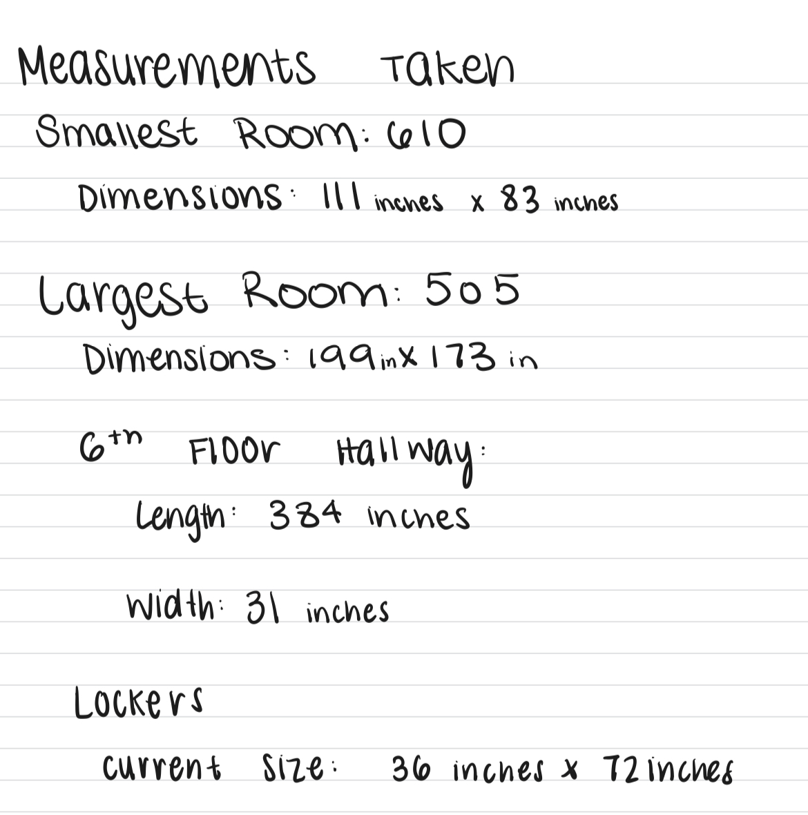

* **Additional Simulations for alternate designs**

## Appendix M: Client Meeting Notes

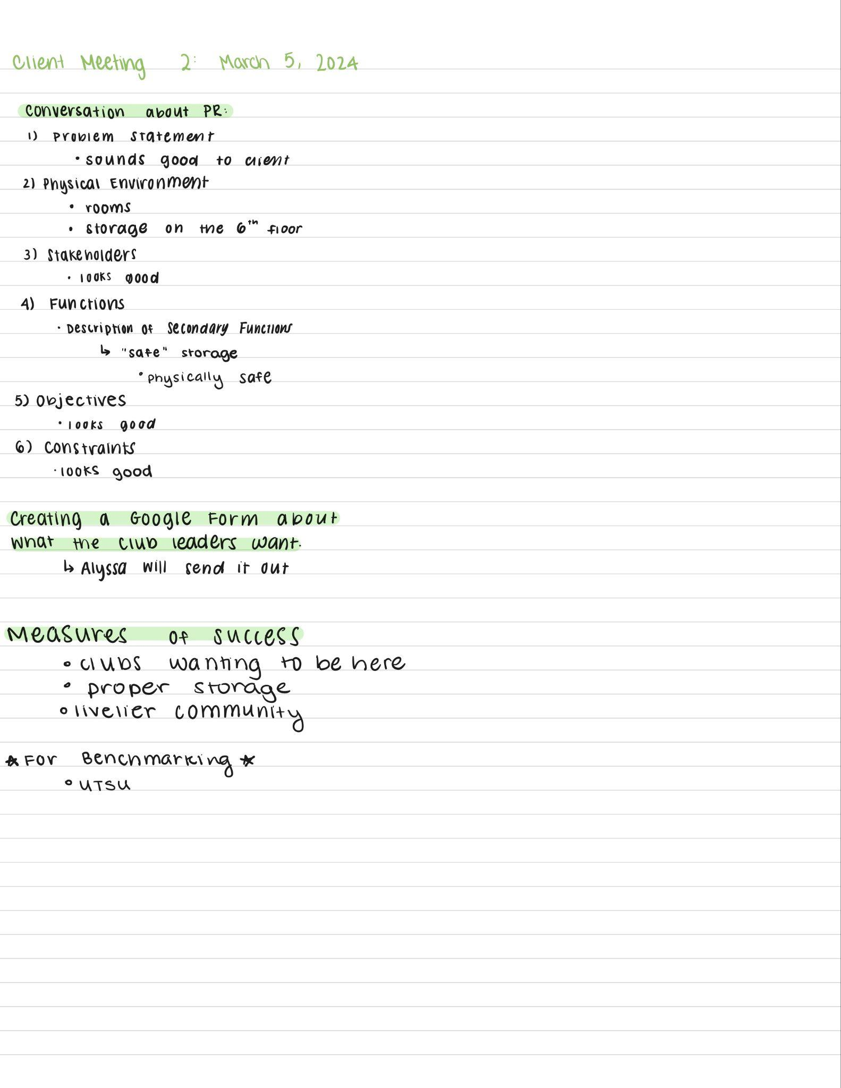

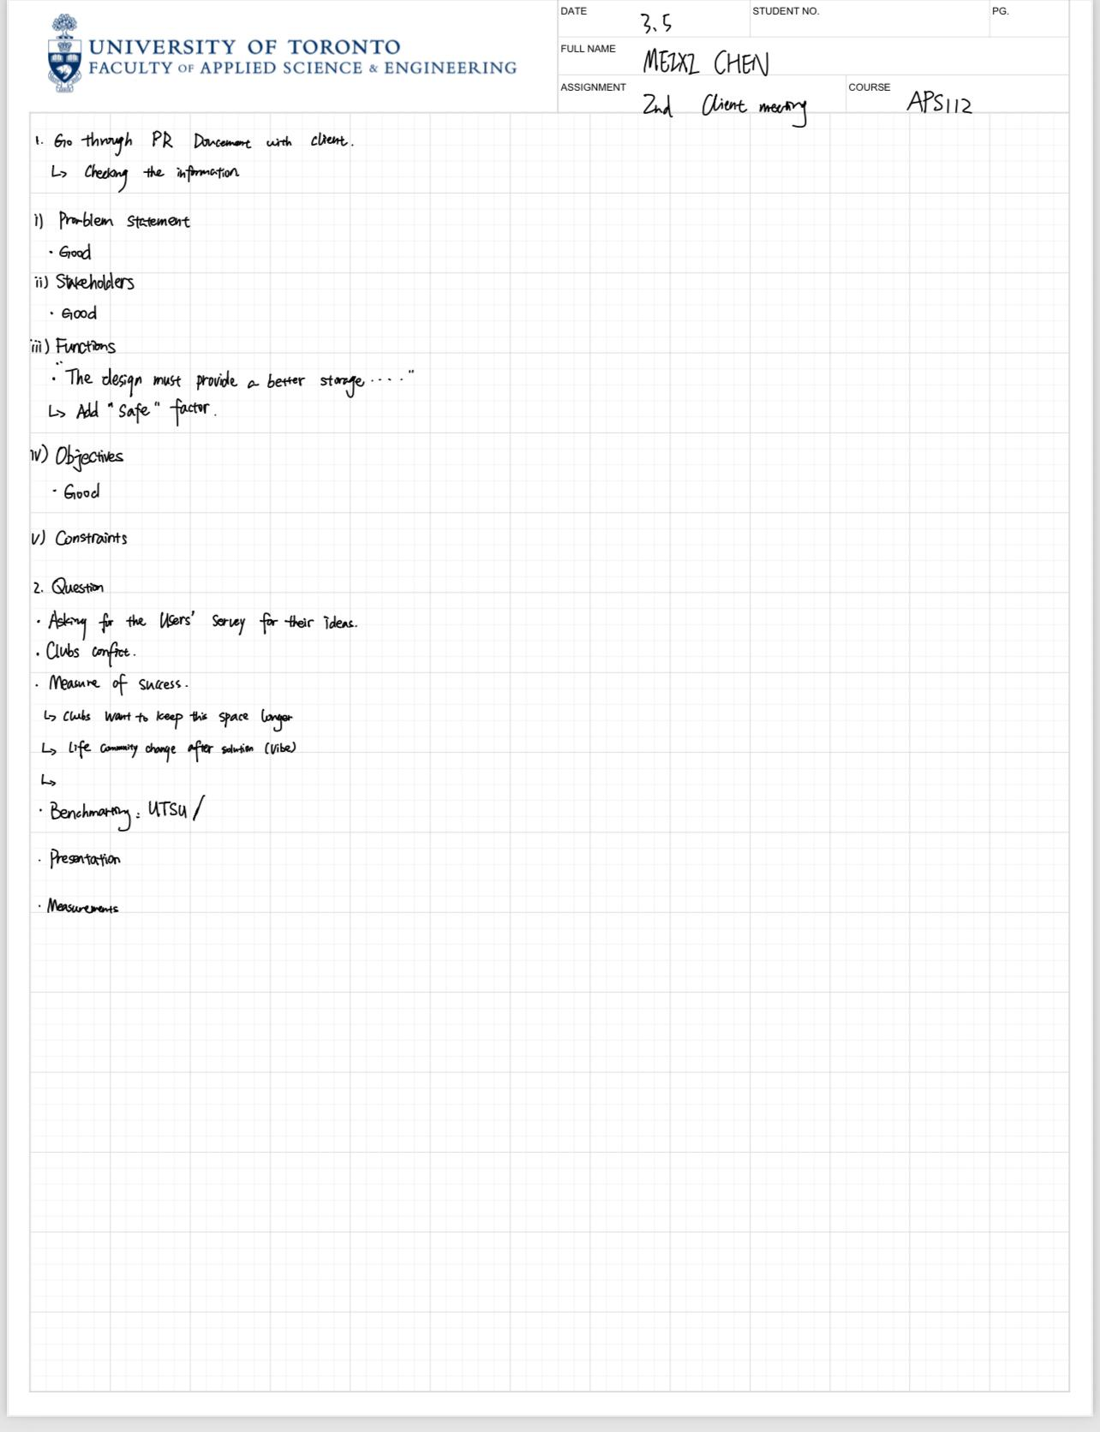

## Appendix N. Black Box Method: Functions

This section outlines the methods employed to derive the design functions. The "inputs" are put through a black box analysis of our design to observe the "outputs".

Table 13. *Black Box Method Analysis of the clubhouse*

| Inputs | → Design → | Outputs |
| --- | --- | --- |
| **Mass** | **Mass** |
| * People are able or unable to travel through the rooms in the building * Low population in the clubhouse * Storage | * Assessment if people can easily move through the rooms within the building efficiently * Assessment if more people are visiting the clubhouse (floors 4,5, and 6) |
| **Energy** | **Energy** |
| * Electricity for lifts * Lights * Electrical appliances. | * Assesses if people can transport around the building * Mechanical energy for appliances * Light energy |
| **Information** | **Information** |
| * Enhance the space efficiency within rooms on the 4th, 5th and 6th floors. * Descriptions of room use * Student club and/or school meetings | * Assessment if community is established * Student discussions regarding various club activities * Presentations * Announcements |

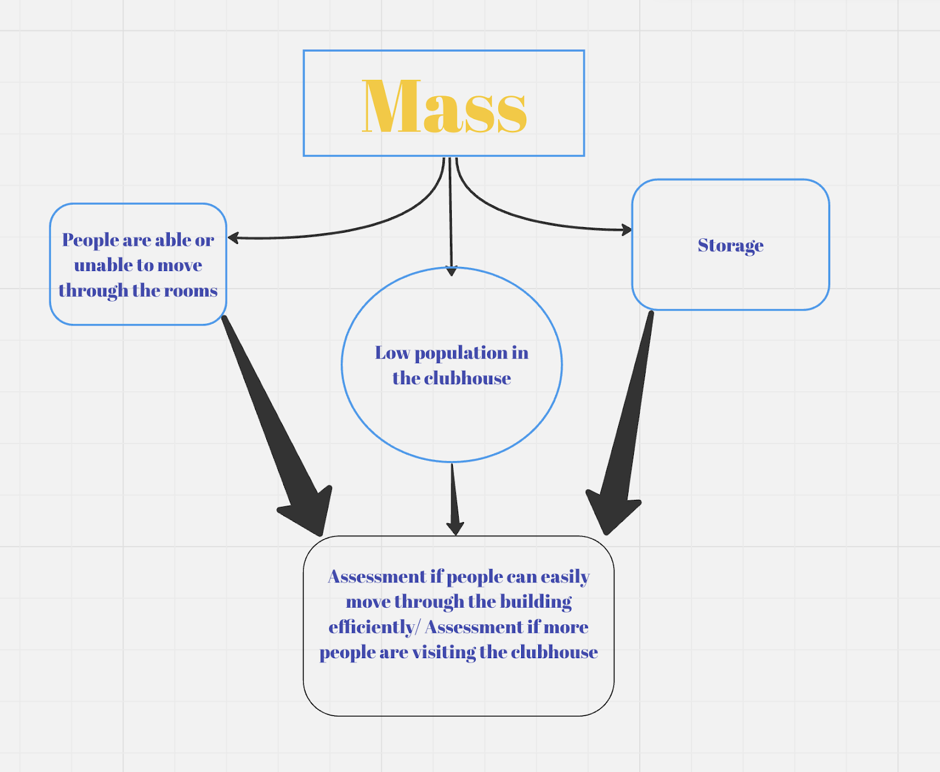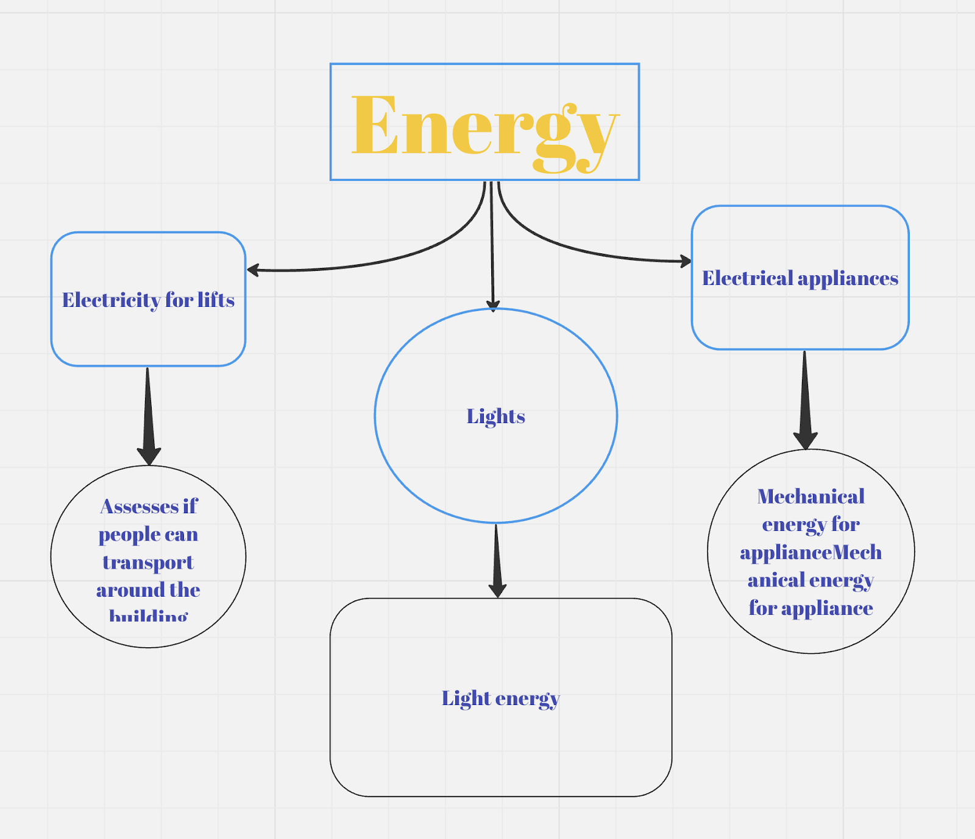

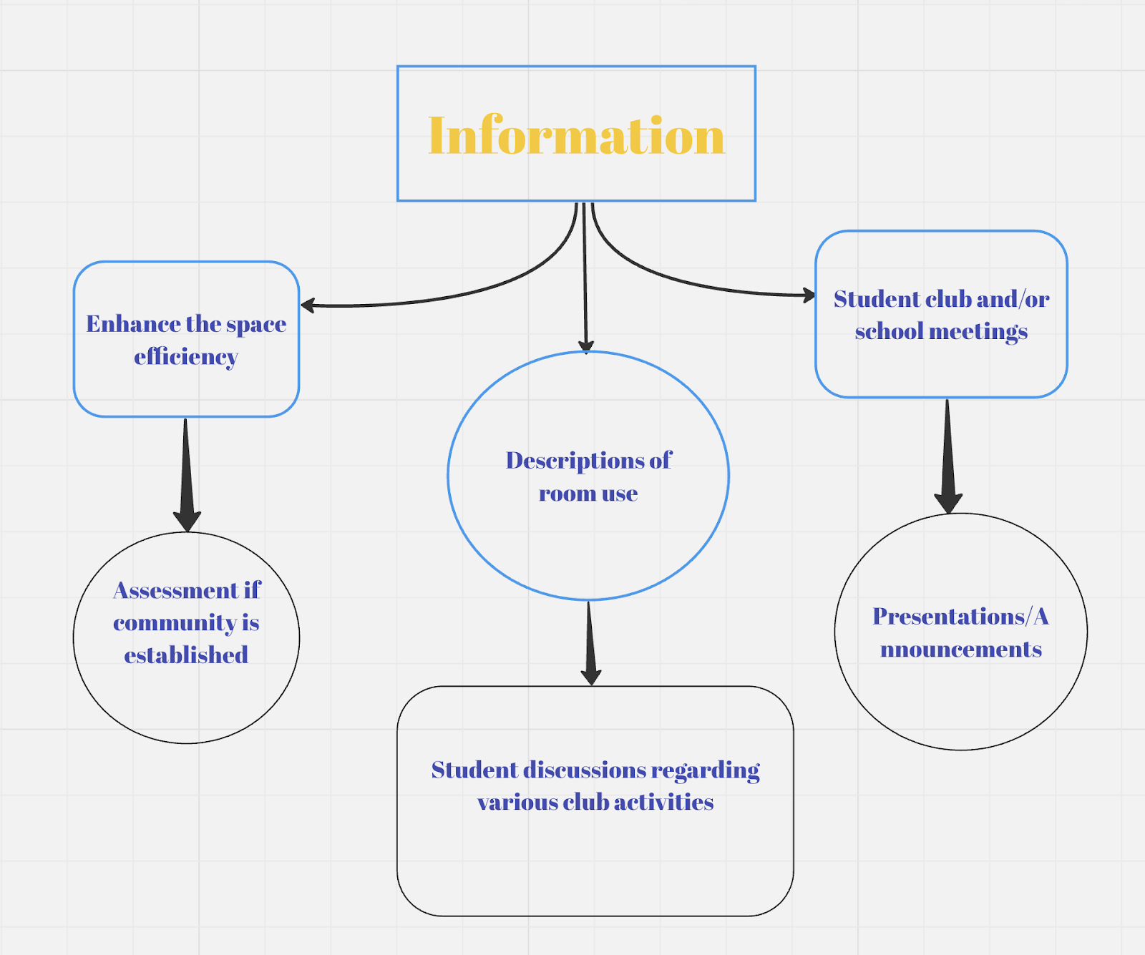

## Appendix O. Price Rational

Design 1: The average shrinkable bench costs $82.28 [18] and will add up to $575.96. Approximate sized cabinets cost $490 [19] and will add up to $4410. Wall-placed shelves add up to $213[20]. Average office tables range from $500-1000[21]

Design 2: Tables with drawers range from $110-$1332 [23] which total to $220-$2664. Small Ottoman seats cost $82 [24] that total to $492. Approximate sized cabinets cost $490 [19] that total to $2450

Design 3: Small Ottoman seats cost $82 [24] that total to $984. Extendable tables with storage have an average price of $420[25] which total to $840. Average baskets that can be hung cost $20 [26] which total $360.

## APPENDIX P. Client survey questions

* Over the last 4 weeks did more members utilize the space?
* Were club members happier/more keen on coming to meetings?
* Did the usage of the clubroom increase? If so, by how much (ratio of people coming before vs after)?
* How is the overall experience utilizing the club rooms?
* How much longer is your club planning on utilizing the space? (i.e. one more year )
* Compared to before the redesign, would you consider using the space more in the long run or short run?
* What aspects of the design made it easier to navigate your room?
* Did certain aspects of the design bring in more members to your club?

# Attribution Table

|  |  |  |  |
| --- | --- | --- | --- |
| **Tutorial #:** | **0114** | **Team #:** | **095** |
| **Assignment:** | **Conceptual Design Specifications** | **Date:** | **25/03/2024** |

**The Attribution Table is a major resource used by your TA in determining whether there was equal contribution to the team assignment. If your TA determines that there was significant under contribution, then they may apply an individual penalty to the under contributing team members’ grade. As a future professional engineer you should NOT sign any document you have not read and do not agree with.**

**The Attribution Table must be completed, signed by all team members, and included as an appendix of your assignment AND uploaded to your MS Teams team channel. Teams who do not submit a completed form, including those that submit an incomplete form, such as one missing a team member’s signature, will receive zero on the assignment. The team may submit a petition to the ESP Office if they feel the lack of signature is through no fault of the team.**

**The Attribution Table should accurately reflect each team members’ contribution to the document. Be sure to keep a copy of this form for the team’s records.**

**If there are irreconcilable differences that are preventing all team members from signing the attribution table then each team member must write a letter (<one page) explaining their position on the difference and suggest a solution. These letters much be submitted to the TA.**

**As with any engineering statement this attribution table must be backed by credible evidence. In most cases this will be found either in the Google Docs document revision history, or your engineering notebook. Making fraudulent claims in an Attribution Table displays intent to deceive and is a serious academic offence.**

|  |  |  |  |  |  |  |
| --- | --- | --- | --- | --- | --- | --- |
| **Section** | **Student names** | | | | | |
| Anjali | Chris | Dora | Lydia | Matthew | Margaret |
| Executive Summary | MR, WD,  ET, FP |  |  | MR, WD, ET | ET, MR, FP | ET |
| Introduction | MR, ET, FP |  |  | MR, ET, FP | ET, MR, FP, |  |
| Service Environment | MR, ET, FP |  | MR, ET | MR, ET, FP | ET, MR, FP | MR |
| Stakeholders | MR, FP | ET | MR, ET | MR, ET,FP | ET, MR, FP | MR |
| Detailed Requirements | MR, ET, FP |  | ET | MR, ET,FP | ET, MR, FP |  |
| Idea Generation | ET, MR, FP |  | WD | MR,FP | WD, ET, MR, FP | ET |
| Idea Selection | MR, FP | ET |  | MR, ET, FP | WD, ET, MR, FP | MR, ET |
| Alternative Design Solutions | RS2, MR |  | ET | ET, MR,FP | WD, MR, ET | ET |
| Proposed Conceptual Design | ET, MR, FP | WD | ET | WD, MR, ET,FP | WD, ET, MR, FP |  |
| Measures of Success | ET, FP | WD,MR,RS1 |  | MR, ET, RS1,FP | WD, ET, MR, FP |  |
| Conclusion | ET, FP | ET | ET | ET, MR,FP | WD, ET, MR, FP | WD MR ET |
| Appendix A |  |  | WD, MR, ET, FP |  | MR | WD, MR, ET, FP |
| Appendix B |  |  |  |  | WD, MR, ET, FP |  |
| Appendix C |  |  | WD, MR, ET, FP |  | WD, MR, ET, FP |  |
| Appendix D | WD, MR, ET, FP |  |  | WD, MR, ET, FP | WD, MR, ET, FP |  |
| Appendix E | WD, MR, ET, FP | WD, MR, ET, FP | WD, MR, ET, FP | WD, MR, ET, FP | WD, MR, ET, FP | WD, MR, ET, FP |
| Appendix F | WD, MR, ET, FP | WD, MR, ET, FP | WD, MR, ET, FP | WD, MR, ET, FP | WD, MR, ET, FP | WD, MR, ET, FP |
| Appendix G | WD, MR, ET, FP | WD, MR, ET, FP | WD, MR, ET, FP | WD, MR, ET, FP | WD, MR, ET, FP | WD, MR, ET, FP |
| Appendix H | WD, MR, ET, FP |  |  | WD, MR, ET, FP | WD, MR, ET, FP |  |
| Appendix I |  |  |  | WD, MR, ET, FP |  |  |
| Appendix J | MR, ET, FP | MR, ET, FP | WD, MR, ET, FP | MR, ET, FP | MR, ET, FP | WD, MR, ET, FP |
| Appendix K | WD, MR, ET, FP | WD, MR, ET, FP | WD, MR, ET, FP | WD, MR, ET, FP | WD, MR, ET, FP |  |
| Appendix L | WD, MR, ET, FP |  |  | WD, MR, ET, FP | WD, MR, ET, FP |  |
| Appendix M | WD, MR, ET, FP |  |  |  | WD, MR, ET, FP | WD, MR, ET, FP |
| Appendix N |  | WD, MR, ET, FP |  | WD, MR, ET, FP | MR |  |
| Appendix O |  |  |  |  | WD, MR, ET, FP |  |
| Appendix P |  |  | WD, MR, ET, FP |  |  | WD, MR, ET, FP |
| Reference List | WD, MR, FP |  | WD | ET,FP | MR |  |

**Fill in abbreviations for roles for each of the required content elements using the abbreviations found on the next page. You do not have to fill in every cell.**

|  |  |
| --- | --- |
| **RS – Research (give details below)**  **WD – Wrote Draft**  **MR – Major Revision**  **ET – Edited** | **FP – Final Proofread of COMPLETE DOCUMENT verifying for flow and consistency**  **OR – Other (give details below)** |

**If you put RS (research) please add a number identifier such as RS1, RS2, etc. Give the research question / topic:**

|  |  |
| --- | --- |
| **RS1:** | **RS1- research to support measures of success** |
| **RS2:** | **RS2 - Measurements using the Ontario Building Code** |

**If you put OR (other) please add a number identifier such as OR1, OR2, etc. Explain the role below:**

|  |  |
| --- | --- |
| **OR1:** |  |
| **OR2:** |  |

**By typing your name below to sign, you verify that you have:**

**● Read the attribution table and agree that it accurately reflects your contribution to the associated document.**

**● Written the sections of the document attributed to you and that they are entirely original.**

**● Accurately cited and referenced any ideas or expressions of ideas taken from other sources according to the standard specified by this course.**

**● Read the University of Toronto Code of Behaviour on Academic Matters and understand the definition of academic offense includes (but is not limited to) all forms of plagiarism. Additionally, you understand that if you provide another student with any part of your own or your team’s work, for whatever reason, and the student having received the work uses it for the purposes of committing an academic offence, then you are considered an equal party in the offence and will be subject to academic sanctions.**

|  |  |  |  |
| --- | --- | --- | --- |
| **Student #1 Name** | **Lydia Messiha** | **Student #5 Name** | **Matthew Ting** |
| **Student #2 Name** | **Anjali Jammulamadaka** | **Student #6 Name** | **Margaret Chen** |
| **Student #3 Name** | **Chris Yip** | **Student #7 Name** |  |
| **Student #4 Name** | **Dora Lyu** |  |  |
|  |  |  |  |